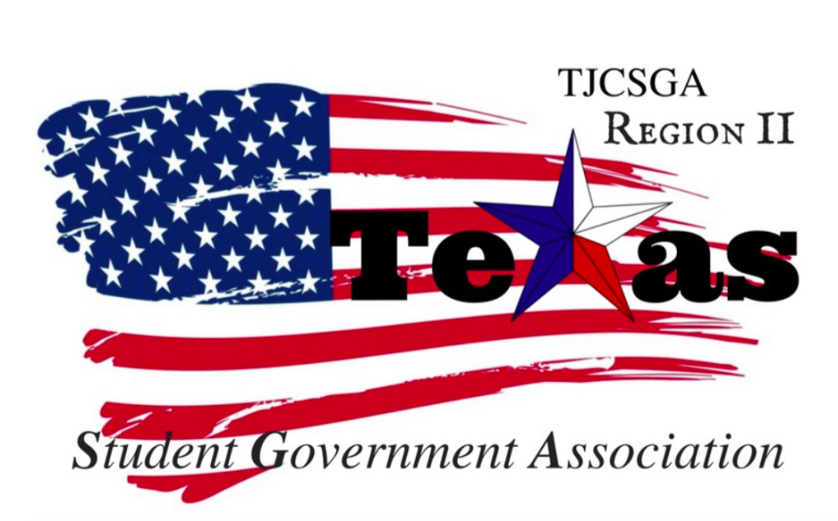
Region II Executive Board Meeting
Friday, September 1st, 2:00 PM, North Lake College - room H206

I. Call to order (2:20 pm)
II. Roll Call- Qurom has been met
III. Reading and approval of the agenda- Approved as written. By voice vote motion 2nd vice president
No Discussion
I’s have it
Motion carried
IV. Reading and approval of the previous meeting’s minutes- Approved as written by voice vote motion entertained by mr.president
2nd by vice president
No Discussion
I’s have it
V. Officer reports
A. Host School
- Edward Sesay, Richland College-Flyers made for the conference were made. A rough draft agenda for the upcoming conference is in the works.Any changes can be made to the poster and the agenda.Just let the host school know. Sponsorship for the national guard is in the works for lunch.There is a law firm that can want to sponsor both conferences for breakfast. They can also be a guest speaker at the conference talking about how to deal with how can you deal with someone that has different views from you and how to react and deal with the situation at hand. How to address different (provides).The layout for the conference was shown for the business meeting and the breakfast and lunch room.
B. Public Relations
- Alyssabeth Lafferty, North Central Texas College-playing out a lot
C. Treasurer
- Luis Gamez, Brookhaven College-3,150.61 cents. Also, I am taking a class at Richland, so it work be easier to work the host school for the conference
D. Parliamentarian
- Juan Prado, Eastfield College- When talking about the sponsorships for lunch does that mean the region won't be coming out of pocket. He works at a Japanese food, but it is a possibility for catering. Then also we have to cater to all the diet concerns.Also, we could have Japanese desert that we can have at the conference
E. Secretary
- Zaire Hickman, Cedar Valley College-No report at this time.
F. Vice President.
- Brittney Taylor, Mountain View College- The committee application will be posted on the TJSGA website. She plans to visit every college to see if anyone wants to apply for the committee chair. Also to speak with the advisors and see if they have a suggestion. September 11-15th will be traveling to all the campuses. The application can be sent VIA email or have paper copies. The google forms will be made into a spreadsheet. Can link, and it will be digitally scanned and submitted.
G. President
- Alexander Bomgardner, North Lake College-UT Dallas offered to print everything for the conference and also have a table. Texas women's university also responded for the breakfast and lunch conference, but they wanted to talk about prices. Will respond and keep them in mind.
H. Advisor
- Dr. Beth Nikopoulos, North Lake College-A new gravel was brought for the board. Nametags are in the works it will have a star with a roman numeral two on it. It will be black and gold. It will have our name, position, and our school. Plus it will have TJSGA on the top of it. Also, pins were suggested for the board.
VL.Advisor Appointment- Kelly Sonnanstine-Motion entertained mr.president as co-advisor for the region two board. So moved Parliamentarian
2nd by public relations
No Discussion
I’s Have it
the end vote was unanimous
VII. Opening announcements-Co-advisor Kellys birthday this weekend.
September 20th there will be a hot air balloon festival that Parliamentarian will be volunteering at the festival. Mr.President next week will be attending LA for scholarship ceremony.
VII. Old Business
A. University Sponsorships Progress- Still looking for lower sponsorships, so we can have schools come in and do recruitment at the conference. They can have a table to interact with the students. Also, we have someone sponsorship for the print out for the conference.
B. Speakers and Decorations progress – The law firm also offered to be a speaker for the conference. The decorations are ready for the conference. The host school will provide bags for everyone that attending the conference.

VIII. New Business
A. Invoices for Member Schools- The treasurer will send out invoices for all the schools. We will create the qualtrics link for the registration for the schools. By the end of next week, it should be sent to all the schools. The flyers will be sent out with the email and the address with all the details for the conference. Once the flyers are done, it will be sent out in the next week or the following week. It will need to send out all the information for the conference and the upcoming events for TJCSGA.
B. Social Media Campaign for Fall Conference
C. Qualtrics Registration
IX. Open Floor- Public Relations Question about the delegate fees without the delegate fees should we put a limit on how many people you can bring to the conference? We shouldn’t limit the people that schools bring. With the qualtrics registration system, it will keep track on how many people the schools will bring. The schools should put in how many people that they bringing to the conference. Registration will close on the 20th for the schools. It shouldn’t be a concern.Our goal is to have as many delegates as possible. National guard should pay the lunch directly. Then the board can just go to Costco or sams for breakfast. The state president is invited to the next region board meeting and the fall conference.
For the committees, we need to plan the outline. For the committee chairs will be invited to the October 26th meeting.Then also have them come October 27th for practice rehearsal for the conference, so they know where the
Richland has a town hall meeting September 12th at 12:30 pm. It will be live streamed on Richlandstudentmedia.com
X. Closing announcements
XI. Adjournment (3:45 pm)

