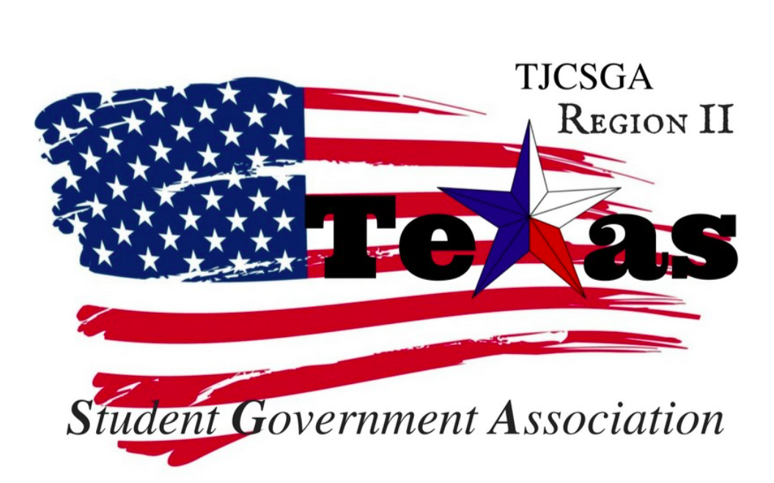
Region II Executive Board Meeting
Friday, November 17th, 2:00pm, Room W38, Mountain View College

I. Call to order (2 pm) Actual Start Time 2:05pm
II. Roll Call
Host school – Edward Essay- present
Treasure - present
Parl. – present
President- present
Trisha john co-chair social committee- present
Sophia – Brookhaven - Social committee chair
Jamie- Brookhaven college- Present
Kina Cole- secretary of social committee
Nabehha – Richland College- Present
Haya – awards committee
Dr. Beth Nikopoulos- North Lake College- Present
Kelly L. Sonnanstine- Richland college – Present
Quorum has been met

- III. Reading and approval of the agenda- Mr. President entertained a motion to adopt the standing rules as written. Host school “So move” the motion
Sophia-Brookhaven college- Seconds the Motion
I’s have it
No discussion

IV. Reading and approval of the October 13th meeting minutes- Trisha- North Lake move to approve the minutes as written baring any grammatical errors. Kina Cole- Mountain View College Seconds the Motion.
I’s have it
No discussion
V. Opening announcements- No Announcements.
VI. Officer reports
A. Host School
- Edward Essay, Richland College- Thank you for all coming to the fall conference. We need the photos from the conference, so we can upload on the website. I would like to propose the agenda for the spring conference. Brochure was passed around. Key note speaker proposed. 87 people at fall conference excluding the speakers. The setup will be different at the conference. There will be longs tables at lunch rather than the round tables. We will encourage people to set with their house rather than their school. Kelly and I discussed, and we need to move the; planning in advanced for the spring conference. Kelly made an Event Brite to email the students off of that website.
B. Public Relations
- Alyssabeth Lafferty, North Central Texas College, not Present
C. Treasurer
- Luis Gamez, Brookhaven College- Hello, the grand total 2574.25 of the conference. Sent an email to NCTC since they paid with cash. I have given them a receipt. The payment has not been put into the account yet. Kelly has sent an email to straighten out this matter.
D. Parliamentarian
- Juan Prado, Eastfield College- No report at this time.
E. Secretary
- Zaire Hickman, Cedar Valley College-Not Present
F. Vice President
- Brittney Taylor, Mountain View College- I have meet with the Awards committee and I would like to thank you all for making the fall conference a success.
G. President
- Alexander Bomgardner, North Lake College- thank the committee chairs and co-chair for coming to the fall conference. Fall conference was successful, but we will be making improvement.
H. Advisor
- Dr. Beth Nikopoulos, North Lake College- conference went great. We had a great turn out. Meeting with the state board to teach them Robert Rules. The account for region will be moved on to Brookhaven.
I. Advisor
- Kelly L. Sonnanstine, Richland College- the conference went well. I will be out of town beginning in December 1st and I want to be back to sometimes in January. Edward and co-chairs will be helping to move forward with the fall conference.

VII. Committee Reports
A. Awards Committee
- Haya Qazi, Richland College- last meeting on November 10th, during the conference logo, school spirt, and community service. From the state the awards were; student of the year, advisor and chapter of the year.
- School spirit, incudes video and supporting documents and max of 20 slides. And showing school spirt during the spring conference.
- Community service- who and how did it effect the students and only one event will be highlighted. Also, ALL REGION II COMPETITIONS ARE DUE A WEEK BEFORE THE FALL CONFRENCE.
- The voting will be taking place during the meeting.
B. Legislative Committee
- Nabeeha Kazmi, Richland College- are committee member has tried to meet and we are staying connected through group-me and email and we have added a table of contents to the Constitution to be voted upon during the general assembly (Spring Conference 2018), our next meeting is undecided, but we will be meeting next month.
C. Recruitment and Retention Committee
- Sophia An, North Lake College- all the list of the emails for contacts, collaborating with social and t-shirt and committee to come up with events. No major changes made on the websites.
D. Resolutions Committee
- Carlos Valbuena, Brookhaven College- co-chair, 10th November 7 possible resolutions; 1. college education- House Bill- 173- higher education curriculum
2. Sanatory setting Senate Bill
3. Appeal to restriction on immigrants in college
4. Against TJCSGA- technical difficulties, problem with the state boards not receiving the awards on time and it not our fault but the state fault. Holding the committee chairs at state responsible for all the awards.
5. Against people being held in jail instead of rehabilitation for drug users.
6.The amount of time people stay in custody, even if they are innocent.
7. Against criminal records for college admissions.
LISTED ABOVE ARE ALL SUGGESTIONS AND THE COMMITTEE AND HAS NOT AGREED UPON ANY PARTICULAR RESOLUTION.
E. Social Committee
- Sophia Huynh, Brookhaven College- In our first meeting we talked about some of the events we are trying to reach out to do 4 events. Flag football for spring, debates amongst the colleges, the winter formal dance – not cost efficient, need funds and want to request funds from the region and want people to pay for the dance and catering for the event. Possible finger foods. Maybe a fundraiser, wants the event to be hosted at Richland College. Will keep you posted. Intellectual competition. All of these are just ideals and not set in stone. The contest will be divided into a game based on subject such as math. Flag football – needs a location. The weather is not in climate, dates are not determined. Needs advertising from the social committee and public relations chair from the region. All events voted on will be hosted next semester. Northlake can host the dance they have a lot of space. No further Discussion.
F. T-Shirt & Cheer Committee
- Victoria Rhodes, North Lake College- working on collaborating with the team, none of the scheduling has worked and has not been able to meet with her team.
VII. Old Business
A. Debrief of Conference
i. Cons
Pledge of the allegiance (Being mindful of those whom are able or unable to stand) and social committee, more food to serve breakfast – e board to serve the breakfast rather than the food being self-served. No markings on the breakfast burritos to determine whether it was vegan or non-vegan. Also, the vegetarian option put to the side. Nobody could hear the speaker. Sound speakers to be on stands. Need help for cleanup for after the region meeting. Photo booth in the beginning of the session rather than by the speaker. People signed up for the conference and did not attend the meeting. Richland had the lowest turnout. Eventbrite will email the event automatically- Kelly stated. Sophia- Northlake- send out email as well. Not blasted as well. President go to each school to promote the conference. Panel for the university went well for those who are going to those school not for others.
ii. Pros
Prado desert was great. The conference was good. Loved the directions. Love the slime for the students to play in. University panel went well. One education session.
iii. Improve for next conference
University Panel could talk more about the life on campus and the environment it has to offer to incoming students.
VIII. New Business
- Sponsors for Spring Conference
Texas national guard for the conference for lunch
Need someone for printing programs sponsor
Need someone to sponsor breakfast
Also need a sponsor for the t-shirt

B. Food for Spring Conference-
Baked potato bar
Table the food – 1000 budget for food 100 people.
Thorn hill catering- look at the menu for food.
IX. Open Floor- Kelly- Advisor-
Presidents please decide a date to meet with the Chancellor (Dr. May) meeting with the college presidents. Prado – looking at community service project and a large social gathering. Next meeting for December 15th, 2017 – cheesecake factory – by north park mall.
X. Adjournment (4 pm) Actual Time of Adjournment 4:17pm

