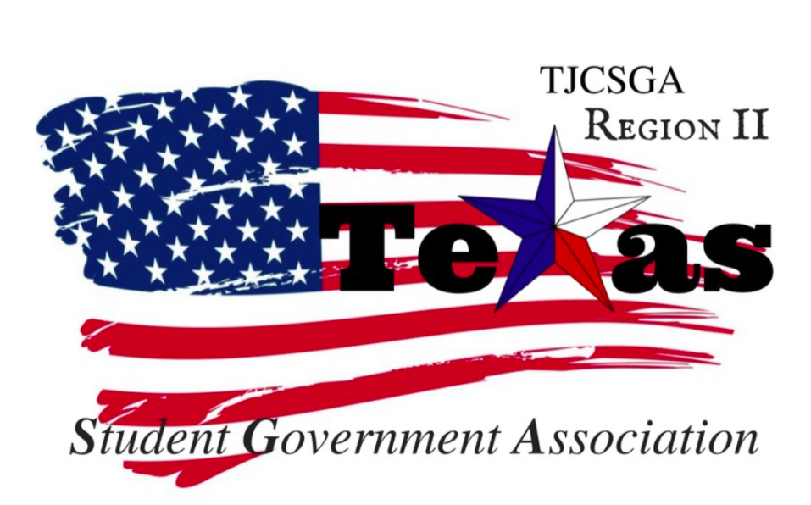
Region II Executive Board Meeting
Friday, March 23rd, 2:00pm, North Lake College

I. Call to order (2:15 pm)
II. Roll Call
III. Reading and approval of the agenda- T-shirt and cheer moved to dismiss the reading and the approval of the agenda. Awards committee second the motion
Parliamentarian-abstained
No discussion
I’s have it
Motion passed

IV. Reading and approval of the February 23rd meeting minutes- Awards committee moved to dismiss the reading and the approval of the February 23rd minutes. T-shirt and chair committee second the motion.
I have it
Motion passed

V. Opening announcements- Ms.Kelly brought up the idea that we can make sure that the awards are done accurately and effectuality. After the awards committee someone will look at the awards and make sure that each schools votes are correct.
If we want to want to alter what goes on at state and that means getting rid of the four votes for each school. That means we will be just going off of score cards.
If you take out the part where you could grade yourself would make a more even better system. We want to make sure we are as transparent as possible. If we want this amendment to be past it will have to be apart of a 2/3thirds vote in front of the whole delegation.
VI. Officer reports
A. Host School
- Edward Sesay, Richland College- Thank you for showing up at the spring conference. Thank you for everyone for helping set and the break down for the conference. Overall, everything went well and I think people really enjoyed themselves. I We had 80 people in attendance. Thank you for giving Richland college for giving this amazing oppoturity to be your host school this past year!
B. Public Relations
- Melissa Larin, North Central Texas College- Throughout the whole conference I was walking around taking pictures of everything and everyone. The pictures have been uploaded to Facebook and instagram. The link to the leaders of tomorrow social gathering will be on Facebook so people can register for the event ahead of time. I also upload all the photos onto the Google documents so everyone will have access to these photos. The new officer photos have been uploaded to the Region Two website along with our new group photo.
C. Treasurer
- Luis Gamez, Brookhaven College- I hope everyone had a great spring break. We have sent emails to all the schools for the invoices for the t-shirts. I also asked for the documentation for the t-shirt order so I can have it on file. We did order a few extra t-shirts and that was figured into the cost. Kelly will send the spreadsheet of all the sizes and the schools. Kelly and I will be passing out the t-shirts when we arrive at states.
D. Parliamentarian
- Juan Prado, Eastfield College –No Report
E. Secretary
- Zaire Hickman, Cedar Valley College
F. Vice President
- Brittney Taylor, Mountain View College- Thanked the executive boards. I am super exited that we are done with all the awards.
G. President
- Alexander Bomgardner, North Lake College- I am very thankful to have served as your president this past year. It has been a true honor.
H. Advisor
- Dr. Beth Nikopoulos, North Lake College- We have to over the logistics of what is going on with the t-shirts and who will be passing them out.
I. Advisor
- Kelly L. Sonnanstine, Richland College- I will be receiving the t-shirts. Before ,states the t-shirts will be

VII. Committee Reports
A. Legislative Committee-not here
- Nabeeha Kazmi, Richland College – not present
B. Resolutions Committee
- Carlos Valbuena, Brookhaven College- We are happy that the resolutions are done and over with . We have to turn in all the Resolutions to the state level.
C. Social Committee
- Drisya john Brookhaven College- We are having our upcoming event. The agenda is in the flyer. We will be borrowing the flags from Richland College. Thank you Kelly for designing the flyer. I sent out an email to all the delegates and the advisor talking about the event. Thank you for Sophia and Melissa thank you for all your help.
D. T-Shirt & Cheer Committee
- Victoria Rhodes, North Lake College- We have ordered the t-shirts. Kelly will be sending me the confirmation letter. We could maybe send a remind 101 for the chants was suggested.We will send out remind 101 to make sure everyone is in the region meetings.
VIII. New Business
A. State Meetings
i. 3 meetings, Thursday Friday Saturday- We will be having 3 meetings at state. Our first meeting will be that Thursday 8:30-9:30pm. We will not have much to do on the first day. If we wanted to change the constitution will be needed to change it 2 weeks before the state conference. During the region 2 orientation meeting we can stress the importance of being ready to run for and region board officer position. On Thursday night at 8pm the officer candidate will be due for anyone that is running. On Friday 3:15-4:45pm will be campaigning during the meeting for the position. It will be the campaign day for the region officers. That Saturday 3:00pm-4:45pm we will elections will take place. We will announce the new officer positions and pin them.
Mr. President will be printing all the passwords necessary for the new board and will leave the passwords.
ii. Reports and state committees-
Awards – Marshay and Jobhable
For the awards committee it will be just a score sheets. If you are a part of the awards at state you will in the awards committee will be in the room all day. The awards are graded and based upon the theme. Sophia hu is responsible for passing out the nomination committee. If you there isn’t a lot of people running for positions. The nominations committee could vote and let the person switch and let the person run for it.
Resolutions will first be voting in a resolutions chair and if you decide that you do want to be chair please let your advisor. The advisors will have to be at every meeting with the resolution committee.
Historian is a open committee anyone that takes photos and send them to the head historian. Judicial will meet if someone does something wrong at the conference or someone repeals the decisions.
B. Campaign Guidelines- We will be using the state campaign guidelines.

IX. Adjournment- At state is professional attire is required the whole time. Thursday is the only day that you can be causal and the evening event you can wear whatever you want.
(3:37pm)

