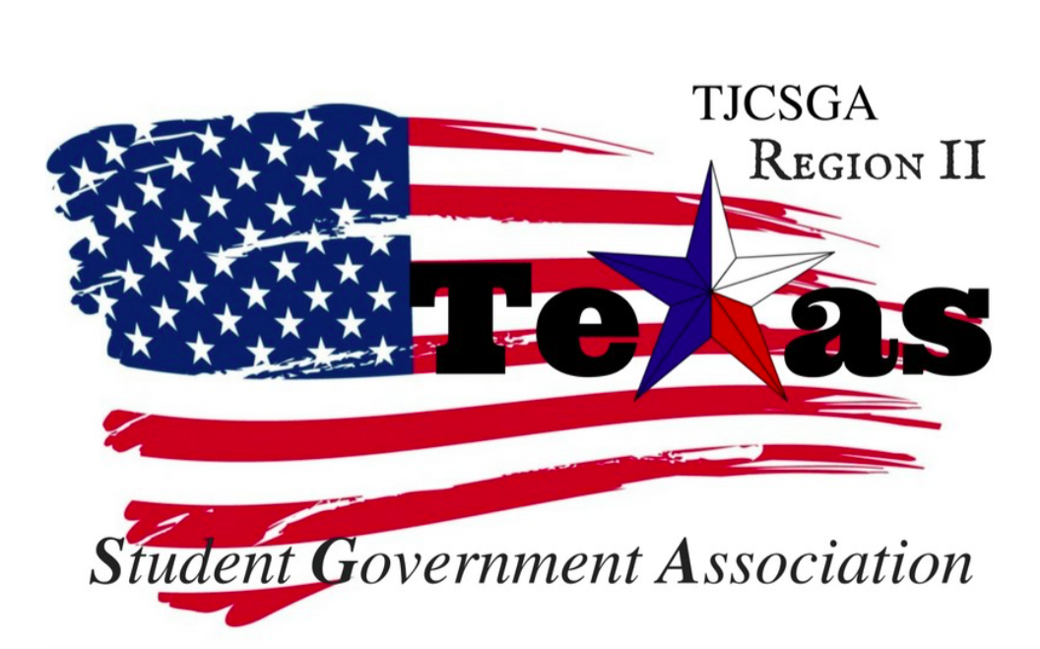
Region II Executive Board Meeting
Friday, February 23rd, 2:00pm, Richland College

I. Photograph
II. Call to order (2:15 pm)
III. Roll Call
IV. Reading and approval of the agenda
V. Reading and approval of the February 8th meeting minutes
VI. Opening announcements
VII. Officer reports
A. Host School
- Edward Sesay, Richland College
B. Public Relations
- Melissa Larin, North Central Texas College
C. Treasurer
- Luis Gamez, Brookhaven College
D. Parliamentarian
- Juan Prado, Eastfield College
E. Secretary
- Zaire Hickman, Cedar Valley College
F. Vice President
- Brittney Taylor, Mountain View College
G. President
- Alexander Bomgardner, North Lake College
H. Advisor
- Dr. Beth Nikopoulos, North Lake College
I. Advisor
- Kelly L. Sonnanstine, Richland College

VIII. Committee Reports
A. Awards Committee
- Haya Qazi, Richland College
B. Legislative Committee
- Nabeeha Kazmi, Richland College
C. Recruitment and Retention Committee
- Sophia An, North Lake College
D. Resolutions Committee
- Carlos Valbuena, Brookhaven College
E. Social Committee
- Sophia Huynh, Brookhaven College
F. T-Shirt & Cheer Committee
- Victoria Rhodes, North Lake College
IX. New Business
A. Intent to Run Form
B. Campaign Guidelines
C. Open Floor and Final Thoughts
X. Adjournment (4 pm)

