COMPETITION GUIDELINES

2019-2020
Please note that the following guidelines were made for the 2020 Convention due to the COVID-19 that will take place in a virtual format.

Awards Committee Guidelines and Responsibilities 2
Competition Requirements and Judging Criteria 3
Student of the Year Award 4
Student of the Year Score Card 5
Chapter of the Year Award 6
Chapter of the Year Award Score Card 7
The Joel Franke Memorial Advisor of the Year Award 8
The Joel Franke Memorial Advisor of the Year Award Score Card 9
Region of the Year Award 10
Region of the Year Award Score Card 11
Video Award 12
Video Score Card 13
Song Award 14
Song Score Card 15
Essay Award 16
Poetry Award 17
Event of the Year Award 18
Community Service Award 19
Other Awards 20
Submitting Awards 21
Virtual Guidelines 22

Poetry Award, Essay Award, Event of the Year Award, and Community Service Award will be voted by the delegates. See page 21 for details.

The Awards Committee shall be composed of up to four (4) members from each region. Each Region President may ask for volunteers from their respective regions to sit on the Awards Committee or may select appointments as needed. Advisor and Student of the Year nominees may not serve on the Awards Committee. The TJCSGA Executive Board shall also appoint up to twelve (12) external judges not affiliated with TJCSGA. The TJCSGA President has final appointment approval.

Members of the Awards Committee are charged with examining each submission assigned to them. These submissions represent countless hours of work and thought. The consideration of these entries is of high importance. The first order of business will be the committee’s selection of chair by a poll vote within the first meeting. The executive board shall appoint up to two (2) advisors to serve as ex- officio members of the committee. In addition, the President of TJCSGA serves as an ex- officio member of this and the other committees excluding the Nominations Committee. There shall be four (4) zoom channels made for this committee. A zoom channel for the entire committee with three (3) break out sections for the sub-committees.

It is the committee member’s responsibility to thoughtfully consider the merits of each submission and not to rush through them. It is mandatory that notes be made on each score card to justify his or her score of the submission. Also, remember that each submission has been completed to the best of the ability of the member colleges with only those resources available to them. If disqualifications occur after the submission process, it is the responsibility of the committee to come to a consensus in these cases and to provide justification for disqualification on the scorecards for the submission.

The committee shall be divided into up to four (4) groups with equal number of region representatives. The external judges divided equally among the groups.

Once scores are submitted, both the highest and lowest scores of each submission will be dropped before tabulations. All scorecards must include committees supporting point values.

The members of the TJCSGA Executive Board are extremely grateful to the Awards Committee members for serving in this committee.

The purpose of these competitions is to allow the opportunity for students to reflect on the role of their SGA within their school and community, with an eye toward preparing future SGA members to continue their work. Successful entries will demonstrate the importance of the interaction of various student groups of their college towards common goals.

Each submission must be submitted to the wetrasfer.com no later than 5:00pm, the Wednesday before the convention. Directions of how to submit awards are on page 21. The name of the college and the type of entry shall be indicated on each item and a completed Nominations Submission form, if required, will be submitted with each entry. Students must create all competition entries. No professional work will be permitted. All entries should be submitted and in an accessible document and/or a video format. It is imperative that all submissions fall within the guidelines of each category, as failure to do so will result in disqualification for that entry. TJCSGA Judicial Policy must not be violated while at convention.

Each member of the Awards Committee shall be provided with a packet of scorecards to rate each entry. The committee will judge each entry solely on the merits prescribed in these guidelines. Deviation from these standards is not allowed. After scores are submitted both highest and lowest score of each submitted will be dropped.

The following awards will be presented for each category:
1st Place - Plaque

2nd Place - Certificate 3rd Place - Certificate
Honorable Mention - to be given at the discretion of the awards committee.

The 1st Place Video and Song will be played for the General Assembly if equipment is available.

It is the responsibility of the Committee Chair to break a tie vote. Any discrepancy in the tie breaking vote will be brought to the Judicial Committee for review.

The TJCSGA Student of the Year will be selected at the State Convention by the TJCSGA Awards Committee from nominees put forth by each Regional Association. One Student of the Year shall be selected. Each member college may nominate one student, and each Region will consider the nominations and select one student from that Region to be considered for TJCSGA Student of the Year.

Nominees for this award should exemplify the best attributes of a college student including, but not limited to academic excellence, involvement at his or her college, and involvement at the regional level. Only information pertaining to the current academic year will be considered for this award; therefore, it is necessary that each region select a nominee who will be attending the State Convention. Nominees may be requested by the Awards Committee to submit to an interview as the committee designates.
Examples of supporting documents could include but are not limited to a resume, transcript, and letters of recommendation etc.

The first-place winner of the TJCSGA Student of the Year Award will receive a scholarship that shall be paid to the college of their choice.

The following requirements have been stipulated for this competition. Failure to abide by any of these rules will result in disqualification:
  - Entries must be no longer than twenty (20) pages in length including all supporting documents but excluding the cover page.
  - Entries must be typed on 8.5”x 11” paper, typed and in a PDF document.
  - Submitted information must not be fraudulent.
  - Entries must be submitted to the wetransfer.com website no later than 5:00pm, the Wednesday before the convention.

Judging criteria will be as follows:
- Student’s involvement during the current academic year in local SGA events.
- Student’s involvement during the current academic year in regional TJCSGA events.
- Student’s academic honors or awards received within the current academic year.
- Student’s membership in honor programs or internships held within the current academic year.
- Student’s participation in clubs, organizations, and civic involvement other than SGA.
- Student’s duties while in college (jobs, family duties etc.).
- Presentation of student entry.

College Name: Student Name: Region: I II III IV V VI

Judging Criteria | Maximum Points | Points Awarded
Local Involvement In SGA | 35
Regional Involvement in TJCSGA | 15
Academics, Honors, and Internships | 20
Other Clubs, Organizations and Civic Involvement | 10
Other duties while in college (Jobs, Family, etc.) | 10
Presentation | 10
Total Points | 100

Length of Submission: pages

Disqualified: (yes/no) If yes, explain below.

Notes:

Awards Committee Member: School: Region (if applicable): I II III IV V VI

Advisor - Ex-Officio Member of the Committee:
School:

Each Region may nominate one-member college to be considered for TJCSGA Chapter of the Year. Nominations should describe in detail the contributions of the nominated chapter, with an emphasis on how that chapter has impacted their individual members, their school, and their community in the current academic year.

The following requirements have been stipulated for this competition. Failure to abide by any of these rules will result in disqualification:
- Entries must be no longer than twenty (20) pages in length including all supporting documents but excluding the cover page.
- Entries must be typed on 8.5”x 11” paper, typed and in a PDF document.
- Submitted information must not be fraudulent.
- Entries must be submitted to the Wetransfer.com website no later than 5:00pm, the Wednesday before the convention.

Judging criteria will be as follows:
- SGA involvement in the current academic year in other local college activities.
- SGA involvement in the current academic year in local community service projects.
- SGA involvement in their regional TJCSGA organizations.
- Presentation of SGA entry.

College Name: Region: I II III IV V VI

Judging Criteria | Maximum Points | Points Awarded
SGA College Activities | 30
SGA Local Community Service | 30
TJCSGA Regional Activities | 30
Presentation | 10
Total Points | 100

Length of Submission: pages

Disqualified: (yes/no) If yes, explain below.

Notes:

Awards Committee Member: School: Region (if applicable): I II III IV V VI

Advisor - Ex-Officio Member of the Committee:
School:

This award is named in memoriam for Joel Franke, who served as an advisor to TJCSGA from Blinn College-Brenham from 1986 to 1995. During his tenure, Mr. Franke worked tirelessly to promote student issues at the state, region, college and local levels.

Each Region may nominate one college SGA advisor to be considered for TJCSGA Advisor of the Year. Nominations should describe in detail the contributions of the nominated advisor, with an emphasis on how that advisor has impacted their individual members, their school, their community, and their state. Of all the awards, this one is the only one to require the entire history of the advisor with TJCSGA, not just the current academic year.

The following requirements have been stipulated for this competition. Failure to abide by any of these rules will result in disqualification:
- Entries must be no longer than ten (10) pages in length including all supporting documents but excluding the cover page.
- Entries must be typed on 8.5”x 11” paper, typed and in a PDF document.
- Submitted information must not be fraudulent.
- Entries must be submitted to the Wetransfer.com website no later than 5:00pm, the Wednesday before the convention.
- Title holder must wait a minimum of 3 years before reapplying.

Judging criteria will be as follows:
- Advisor’s role in their local SGA.
- Advisor’s role in community events not associated with SGA.
- Advisor’s role in TJCSGA regional activities
- Advisor’s role in TJCSGA State activities.
- Presentation of Entry.

College Name: Advisor’s Name: Region: I II III IV V VI

Judging Criteria | Maximum Points | Points Awarded
Advisor’s Role in local SGA | 35
Advisor’s Role in community | 30
Advisor’s Role in TJCSGA regional activities | 15
Advisor’s Role in TJCSGA State activities | 10
Presentation | 10
Total Points | 100

Length of Submission: pages

Disqualified: (yes/no) If yes, explain below.

Notes:

Awards Committee Member: School: Region (if applicable): I II III IV V VI

Advisor - Ex-Officio Member of the Committee:
School:

All entries will be submitted by the region interested. Nominations should describe in detail the contributions of the nominated region, with an emphasis on how that region has impacted their individual members, region, and community in the current academic year.

The following requirements have been stipulated for this competition. Failure to abide by any of these rules will result in disqualification:
- Entries must be no longer than twenty (20) pages in length including all supporting documents but excluding the cover page.
- Entries must be typed on 8.5”x 11” paper, typed and in a PDF document.
- Submitted information must not be fraudulent.
- Entries must be submitted to the Wetransfer.com website no later than 5:00pm, the Wednesday before the convention.

Judging criteria will be as follows:
- Online presence
- Community involvement
- Integration of regional or state theme
- Regional conferences
- Support of initiatives

College Name: Region: I II III IV V VI

Judging Criteria | Maximum Points | Points Awarded
Online Presence | 30
Community involvement | 25
Theme | 25
Conferences | 10
Support of initiatives | 10
Total Points | 100

Length of Submission: pages

Disqualified: (yes/no) If yes, explain below.

Notes:

Awards Committee Member: School: Region (if applicable): I II III IV V VI

Advisor - Ex-Officio Member of the Committee:
School:

The video should show how your local SGA embraced the TJCSGA theme for this year.

The following requirements have been stipulated for this competition. Failure to abide by any of these rules will result in disqualification:
- Entry must be an original work done by students of your college.
- Entry must be submitted in an AVI, MPG, or WMV file format e-mailed to us that is shareable.
- Entry must be no longer than 6 minutes in length, including dead time.
- Entries must be submitted to the Wetransfer.com website no later than 5:00pm, the Wednesday before the convention.

Judging criteria will be as follows:
- Appropriate use of the TJCSGA Theme.
- Demonstrated creativity.
- Well-organized and appropriate content.
- Appearance is aesthetically sound.
- Live-action footage of members of your SGA must be presented in video.

College Name: Region: I II III IV V VI

Judging Criteria | Maximum Points | Points Awarded
Use of TJCSGA State Theme | 20
Creativity | 20
Organization and Content | 20
Appearance | 20
Live Action | 20
Total Points | 100

Time on DVD/flash drive:

Disqualified: (yes/no) If yes, explain below.

Notes:

Awards Committee Member: School: Region (if applicable): I II III IV V VI

Advisor - Ex-Officio Member of the Committee:
School:

Song should show how your local SGA embraced the TJCSGA theme for this year.

The following requirements have been stipulated for this competition. Failure to abide by any of these rules will result in disqualification:
- Entries must be no longer than four (4) minutes in length, this including dead time.
- Lyrics and music must be original work written by students of your college.
- A typed lyric sheet must be turned in with the entry typed on 8.5”x 11”, PDF document, and must have a cover page.
- Submitted information must not be fraudulent.
- Entries must be submitted to the Wetransfer.com website no later than 5:00pm, the Wednesday before the convention.

Judging criteria will be as follows:
  - Appropriate use of TJCSGA theme.
  - Demonstrated creativity.
  - Clarity.
  - Appropriate content (lyrics).
  - Quality of performance.

College Name: Region: I II III IV V VI

Judging Criteria | Maximum Points | Points Awarded
Creativity | 20
Use of TJCSGA Theme | 20
Clarity | 20
Contents/Lyrics | 20
Quality of Performance | 20
Total Points | 100

Length of Submission:

Disqualified: (yes/no) If yes, explain below.

Notes:

Awards Committee Member: School: Region (if applicable): I II III IV V VI

Advisor - Ex-Officio Member of the Committee:
School:

Entries into this category should incorporate a variety of activities provided by the Student Government Association of your school and should incorporate actions of your student government’s impact on campus. This competition encompasses the year your SGA has had and does not examine any one event.

The following requirements have been stipulated for this competition. Failure to abide by any of these rules will result in disqualification:
- Essay must be an original work done by students of your college.
- Entries must have continuity and be no more than four (4) pages in length excluding the cover page.
- Entries must be typed on 8.5”x 11” paper, typed and in a PDF document.
- Submitted information must not be fraudulent.
- Entries must be submitted to the Wetransfer.com website no later than 5:00pm, the Wednesday before the convention.

Judging criteria will be as follows:
- Use of events held by your college.
- Appropriate use of TJCSGA Theme.
- Impact on college campus.
- Demonstrated creativity.
- Appropriate content.
- Description of community service.
- Well-organized structure.

Poetry should show how your local SGA embraced the TJCSGA theme for this year.

The following requirements have been stipulated for this competition. Failure to abide by any of these rules will result in disqualification.
- Entries must be no longer than two (2) pages in length excluding the cover page.
- Poetry MUST be original work written by a student(s) at your college.
- Entries must be typed on 8.5”x 11” paper, typed and in a PDF document.
- Entries must be submitted to the Wetransfer.com website no later than 5:00pm, the Wednesday before the convention.

Judging criteria will be as follows:
  - Appropriate use of TJCSGA theme
  - Demonstrated creativity
  - Appropriate content
  - Clarity

Each SGA submitting an entry must choose one event for the Event of the Year Award held by your college’s SGA during the current academic year.

The following requirements have been stipulated for this competition. Failure to abide by any of these rules will result in disqualification:
- Entries must be accompanied by supporting documents (such as photographs, flyers, newspaper articles, etc.).
- Entries must include a letter verifying that the event that took place, on college letterhead written and signed by a college administrator.
- Entries must be no longer than ten (10) pages in length, including all supporting documents, but excluding cover page.
- Entries must be typed on 8.5”x 11” paper, typed and in a PDF document.
- Submitted information must not be fraudulent.
- Entries must be submitted to the Wetransfer.com website no later than 5:00pm, the Wednesday before the convention.

Judging criteria will be as follows:
  - SGA involvement in the current academic year in local college activities.
  - Demonstrated creativity.
  - Appropriate content and clarity.
  - Supporting documents.

Each SGA submitting an entry must choose one project for the Community Service Award organized and supported by your college’s SGA during the current academic year.

The following requirements have been stipulated for this competition. Failure to abide by any of these rules will result in disqualification:
- Entries must be accompanied by supporting documents (such as photographs, flyers, newspapers articles, etc.).
- Entries must be no longer than ten (10) pages in length, including all supporting documents but excluding the cover page.
- Entries must be typed on 8.5”x 11” paper, typed and in a PDF document.
- Submitted information must not be fraudulent.
- Entries must be submitted to the Wetransfer.com website no later than 5:00pm, the Wednesday before the convention.

Judging criteria will be as follows:
  - Community Impact.
  - Demonstrated creativity.
  - Appropriate content and clarity.

Only one (1) winner will be chosen for each of these category awards.

Sweepstakes Award:

Entries in the Video, Scrapbook, Essay, Song, Poetry, Event, and Community Service competitions will be eligible for the TJCSGA Sweepstakes Award. Each entry will be awarded a minimum of 1 point for being submitted. The following formula will be used for determining the Sweepstakes winner.

4 Points – 1st Place 3 Points – 2nd Place 2 Points – 3rd Place
1 Point - Submission

Texas Legend Award

The Texas Legend award, is an award reserved for an advisor who through their years of service, have guided and shaped the organization. Any member wishing to nominate an advisor for the Texas Legend award, should submit a letter of nomination to the State Advisor (advisor@tjcsga.org) prior to the start of the State Convention. Please limit your nomination to two (2) pages and address these five (5) items below:
- An overview of the individual (Higher Ed career, years of service, responsibilities)
- An overview/highlights/contribution with their local SGA
- An overview/highlights/contribution with their Region
- An overview/highlights/contribution at the State level
- Any information that you would like to consider.

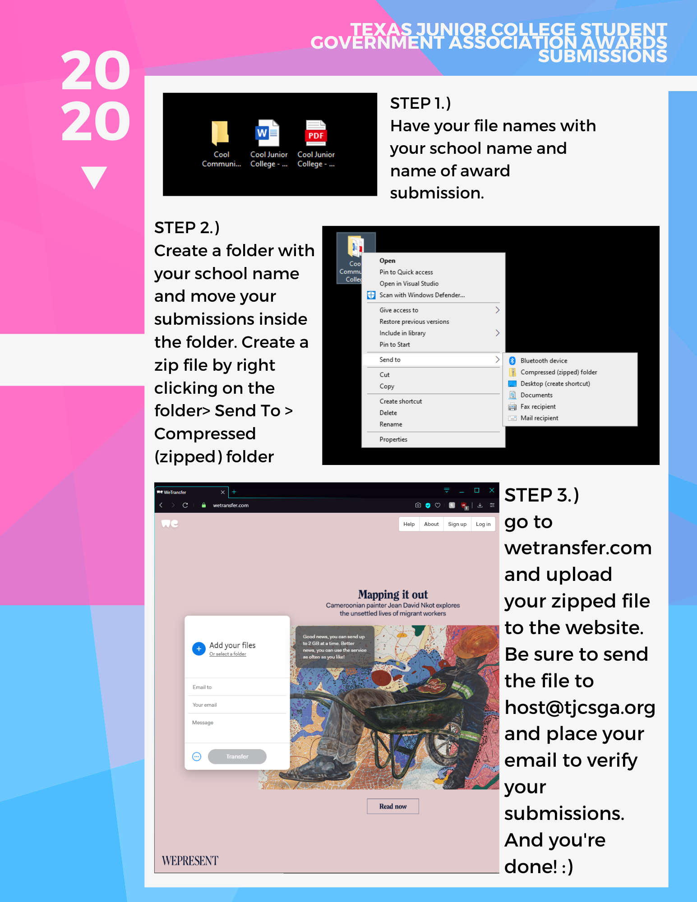
Tip: If you are having trouble, there is a Youtube video up. Type in https://youtu.be/5xfasXihXBg or go to the tjcsga.org website for the link.

Due to the COVID-19, the 2020 TJCSGA Convention will now be held virtually. This page will explain the guidelines the Award Committee must follow. If there is any questions that were not answered here, please reach out to the State Advisor Elect at ae@tjcsga.org.

- The committee shall be composed of up to four (4) members from each region.
- The first order of business will be committee’s selection of chair which would be by poll that the committee members only have access to.
- Only the members of the committee will be allowed into the Zoom calls and cannot be substituted with another student.
- One person of the committee and subcommittee will share a screen within the call.
- Each sub-committee must consist of one delegate from each region.
- Each person must turn in the scores on Google Docs thirty (30) minutes before the last General Assembly.
  - The Google Doc will be provided by the State Advisor Elect.

Each award that will be put towards the delegation will be voted as follows:
- Each score card for the award will be sent only once to the College with the e-mail we have on record.
- The college will use the score card to place their vote for the award.
  - Each college will only receive one score card, so the delegates of the college will discuss and agree on how the score card will be filled out.
- The person with access to the Google Doc will input the scores that will automatically add into scores.
  - Due to the score card being submitted to Google Doc, the school may only submit one score card.
- Each college must turn in the scores on the Google Doc thirty (30) minutes before the last General Assembly.
- The winners will be announced at the last General Assembly.

