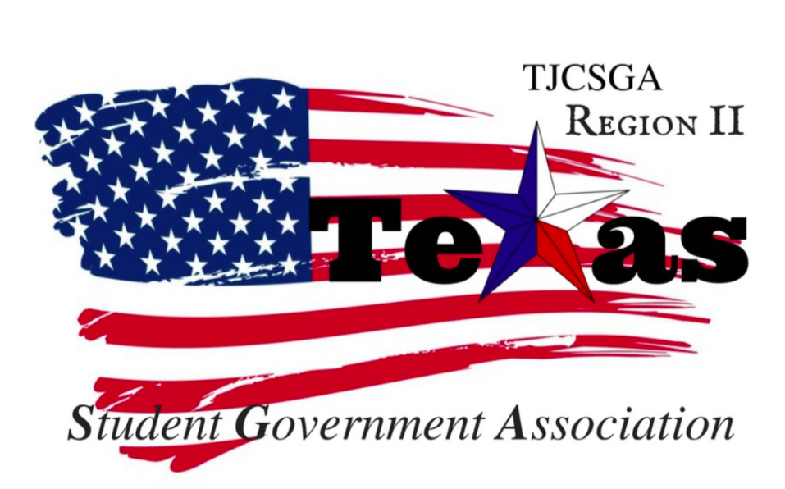
Region II Meeting
Thursday, April 6th ,2018 , 3:15pm, TJCSGA State Conference

I. Call to order (3:28pm)
II. Roll Call
III. Reading and approval of the agenda- Northlake College moved to dismiss the reading and the approval of the agenda. Richland College seconds the motion
No discussion
I’s have it
Motion passed

IV. Reading and approval of the March 3rd ,2018 meeting minutes- Brookhaven College moved to table the reading and the approval of the March 3rd ,2018 meeting. Northlake College seconds the motion.
No discussion
Nays have it
Motion fails

The chair entertains a motion to table the reading and the approval of the agenda Spring conference minutes until April 7th ,2018. Northlake College seconds the motion.
No discussion
I’s Have it

Roll Call –
Brookhaven College 13 delegates 2- advisors
Cedar valley College 6- delegates 2- advisors
Collin College 1- delegates 1- advisor
Eastfield College 10- delegates 2- advisors
El Centro College 7 – delegates 1- advisor
Mountain View College 3- delegates 1- advisor
Northlake College- 15 delegates 2- advisors
Richland College 4- delegates 1- advisor
Tarrant College 7 delegates 1- advisor
Tarrant county North West 6 -delegates 2-advisors
NCTC -13- delegates 2- advisors

V. Opening announcements-
VI. Officer reports
A. Host School
- Edward Sesay, Richland College- Keep up the good work guys! The end is almost here.
B. Public Relations
- Melissa Larin, North Central Texas College- I can still taking pictures throughout the conference and they will be posted on the regional website, Facebook and Instagram pages. Please use the state hash tag and the region two hash tag when you upload photos online.
C. Treasurer
- Luis Gamez, Brookhaven College- I am just waiting on the waiting for verification of payments of the t-shirt orders. There has been no change in the account. Thank you to the E-board for everything. I am really going to miss everyone and being on the board.
- .
D. Parliamentarian
- Juan Prado, Eastfield College –. I hope everyone is having a great time. Please be curious to our state president. If you are speaking to her please make sure you address her first ,state yiour name and school then speak. Please know what you are voting for in the general assembly. If you know you want to speak in general assembly make sure you sit close to the microphone.
E. Secretary
- Zaire Hickman, Cedar Valley College-. All the minutes are done. The internet has been giving us a hard time . But everything should be posted or sent by the April 7th,2018.
F. Vice President
- Brittney Taylor, Mountain View College-
G. President
- Alexander Bomgardner, North Lake College- I am sorry that all the chaos that happened in the general assembly. I want to make sure that everything is run correctly. When voting for things in the general assembly please make sure you let the people around you know what they are exactly voting for.

H. Advisor
- Dr. Beth Nikopoulos, North Lake College- I am very proud of regional two stepping up in the general abmessbly seconding motions and knowing your Robert rules.
- I hope that none of the things that happened at the hotel last night will not take place on region two behalf. There is no alcohol allowed at all on this trip.
I. Advisor
- Kelly L. Sonnanstine, Richland College-

VII. Committee Reports
A. Legislative Committee-not here
- Nabeeha Kazmi, Richland College – Please make sure that if you do have any questions. Please do not be afraid and ask
B. Resolutions Committee
- Carlos Valbuena, Brookhaven College- I am super proud of region two. From the five of the resolution that were brought in front the state board .There was three resolutions from Region two submitted to the state level.
C. Social Committee
- Brookhaven College- No report

D. T-Shirt & Cheer Committee
- Victoria Rhodes, North Lake College-
- Chant one is – SGA region two, Student Leaders Breaking through
- Chant two- President- Who are we , ALL- Region two , President -One voice,
- ALL- Breaking through
- Chant three- Who house ,two house , Who’s house ,two house
- Ain’t no party like a twos house party ,cause a twos house party don’t stop

Awards committee- no report
Judicial committee- no report

VIII. New Business– Campaign skits for region two
We will still be taking applications until April 7th, 2017. The official region two email is – region2tjcsga@yahoo.com
You can find the intent to run form for the region is located on the website.
If your advisor is present your advisor can email the official region campaign form to the region email.

The chair entertains a motion to recess for 15 minutes.
Northlake College seconds the motion.
No discussion
I’s Have it
Motion

4:09 The meeting was called back to order

Region Two Schools Exective Board –Intent to run
Brookhaven –Secretary
Tarrant County North West- Treasurer and Parliamentarian
Northlake – Parliamentarian
Tarrant county North West – Treasurer
Mountain view-Public Relations
NCTC- Host School
The campaign skits and speeches will take place tomorrow. The voting will take place tomorrow and swearing in.

Closing announcements – The campaign speeches have to be under 5 minutes. You do not have to use the whole 5 minutes.
Each school has 4 votes per position. If you want to split your votes you can do that for the same position. In order to vote you must had paid your dues to the region. If you can show the proof of payment you can partake in the election.

IX. Adjournment-
(4:16pm)

