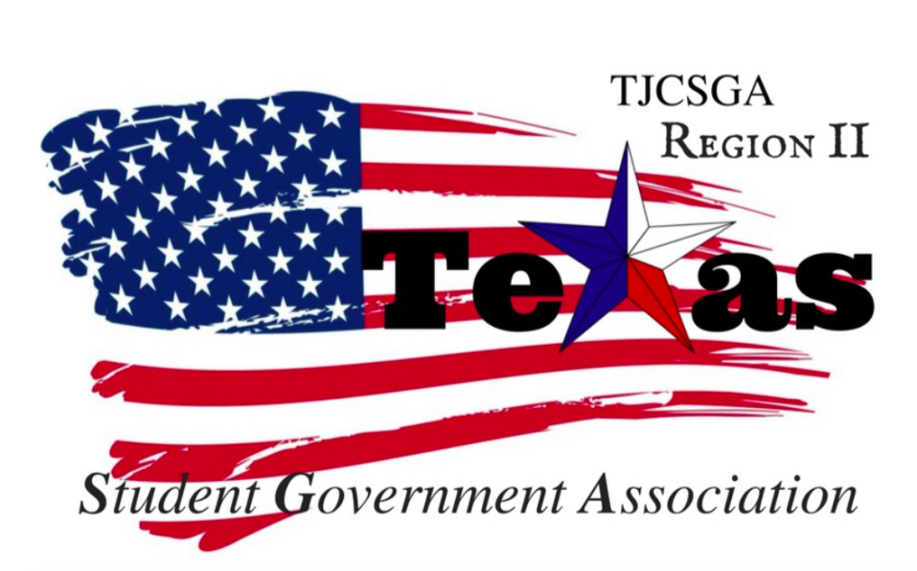
Region II Executive Board Meeting
Friday, April 21st, 3:30 PM, Richland College - room EO36

I. Call to order – 3:35pm
II. Roll Call - Quorum has been met
Richland Advisor Kelly Sonnanstine in attendance
III. Reading and approval of the agenda- approved by voice vote as written, motion made by host school, 2nd by treasurer
IV. Reading and approval of the previous meeting’s minutes (tabled to next meeting, motion by Vice president, 2nd by host school, approved by voice vote)
V. Opening announcements
VI. Officer reports
A. Host School-present
- Edward Sesay, Richland College- Thanked everyone for coming to the meeting
B. Public Relations-present (skype call)
- Alyssabeth Lafferty, North Central Texas College- Very excited about the new camera purchase . Great pictures for new upcoming year
C. Treasurer-present
- Luis Gamez, Brookhaven College- Account balance $3,140.61. Northlake is owed $31.52 for missing t-shirts. Brookhaven is owed $31.52 for t-shirts missing.
D. Parliamentarian-present by proxy (facetime & phone call)
- Juan Prado, Eastfield College-no report
E. Secretary-present
- Zaire Hickman, Cedar Valley College-Thanked everyone for being there.
F. Vice President-present
- Brittney Taylor, Mountain View College- no report
G. President-present
- Alexander Bomgardner, North Lake College-no report
H. Advisor-present
- Dr. Beth Nikopoulos, North Lake College- Suggest that SGA have a meeting with the chancellor. To have the meeting set up with the chancellor get in contact with Paige to set up the meeting in July or August. Then also have all local Region Two SGA presidents attend the state officer meeting during the summer or fall to understand the structure of the organization. Region Two to have a presence and a input at the state officer meeting.
VII. Old Business
A. Reimbursement for unreceived T-Shirts at State Convention- Motion approved by voice vote to make T-shirts available at the State conference in the spring. Instead of handing t-shirts out at the region conference. Northlake did not receive state and some region shirts.
B. May 12th transition party at Brookhaven College –Pushing back the time on the 12th. Have the public relations officer make flyers and send them out to all the colleges. So there can be more participation and involvement between the colleges .Have the all previous board to attend so they can pass off all the records they have and also asking what they wanted to get done but could not accomplish.
Treasurer motioned to spend the maximum of $200 on May 12th on 11am.
2nd by Vice President.
Approved by voice vote

VIII. New Business
- Officer meeting dates and locations-
May 12th transition party at Brookhaven College 11am
Meeting at the leadership retreat May 15th-18th TBA
June 14th 1pm-3pm Northlake
July 12th 1pm-3pm Brookhaven
August 17th 2pm-4pm Richland
September 1st 2pm-4pm Northlake
September 15th 2pm-4pm Brookhaven
September 29th 2pm-4pm Richland College
SEP- OCT additional officer meetings tabled to next officer meeting (moved by host school, seconded by treasurer, approved by voice vote)
B. Committees –tabled to next meeting at the leadership retreat
i. Chairs / schools to reach out to
ii. Responsibilities and functions
iii. Application
iv. Selection Process
C. Fall and Spring conferences
i. Dates
Fall conference October 28th at Richland chosen due to not conflicting with Phi Theta Kappa events on October 14th / 21st and November 5th / 11th
Spring conference February- TBA
ii. Standing rules - skipped in the interest of time
iii. Robert’s rules before business meeting - skipped in the interest of time
D. Officer goals and desires- Designated as homework for each officer to decide what he or she wishes to accomplish in the upcoming year
E. Individual school and Local SGA goals and desires- Public Relations officer is working on doing more the students and working towards the students wants and goals as being president for her local SGA.
F. Preparation to win Region of the Year – Working toward winning Region of the again this upcoming year.
G. Strategies to get more schools and delegates involved at Region and State- Posting pictures of the previous award from the past year to get an idea of what to submit at Region and States. For everyone to have a base line to go off of. Also suggested having a breakout session during the fall to explain the award process and the judges are grading for. Reaching out to schools by having the executive board and visit the campuses not involved. Also visiting Terrell college on the way to leadership retreat.
IX. Closing announcements
X. Adjournment-5:06pm

