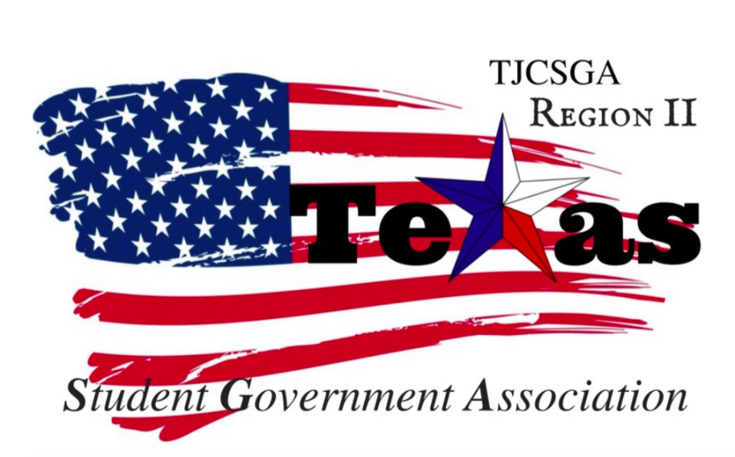
Region II Executive Board Meeting
Friday, September 15th, 2 PM, Brookhaven College

I. Call to order (2 pm)
II. Roll Call- Qourm has been met
III. Reading and approval of the agenda- Approved as written. By voice vote motion
2nd –public relations
discussion-The pin idea was shown to the officer board. Nametags were ordered.
I’s have it
Motion Carried
IV. Reading and approval of the September 1st meeting minutes-Approved as written and Baring room number being wrong
entertained by host school-
Parliamentarian-2nd
No discussion
I’s have it
V. Opening announcements- Mr.President attended LA this past weekend for the point foundation which is the LGBT community scholarship.The weekend was great. Sander stated that if you have a chance to go to grand central market in LA.
Treasuer said he got a sample invoice and had a question about where to send the invoices. Beth said to compare notes with sander. Then send it to the advisor. For the sample invoice just edit it for every college including the amount and college name and the amount for region dues. Dues and registration fees are separate. The state president will drop in our regional meeting at 3 pm.
VI. Officer reports
A. Host School
- Edward Sesay, Richland College- Nametags samples were made for the conference. The labels are 2X4 which they are made from shipping labels.But for the conference, they can be printed on regular name tags labels. Sample programs were created and shown to the board. They included the sponsorships on the back.Just need to add standing rules. We just need a key note speaker the conference. Lunch sponsorship was contacted today. The cost of lunch will be $1,075. Since a sample of the program was made, we can make changes and add-ons.UTD would need the information 2-3weeks in advance to print all the things for the conference.
B. Public Relations
- Alyssabeth Lafferty, North Central Texas College- Website is updated. Just need Treasurer's bio for the website. To get our faces things will be posted on the facebook page getting people pumped for the conference.
C. Treasurer
- Luis Gamez, Brookhaven College-The balance of the account is $2,986.18. An email and invoice will be sent out to all the schools. Then it will include the agenda for the meeting at the conference in a word document so it can be attached to the email. The email will be sent to the advisors as a BC copy. Beth stated that next week would be a very good time to talk more about the invoices for help. Also, you can get help from Kelly from Richland on Tuesday to get help more with invoices.
D. Parliamentarian
- Juan Prado, Eastfield College- The Japanese restaurant is willing to provide dessert for the conference it will be like a cheesecake dessert.It will be confirmed by next week Friday.
E. Secretary
- Zaire Hickman, Cedar Valley College- Willing to sent out the minutes from the meeting again because it was all bold in the email.
F. Vice President
- Brittney Taylor, Mountain View College- not present
G. President
- Alexander Bomgardner, North Lake College- Lunch, t-shirt, breakfast and print sponsorships we all have taken care of. Since all this is paid for it makes the majority of the cost for the conference paid for.
H. Advisor
- Dr. Beth Nikopoulos, North Lake College-Nametags were ordered are being sent which was $71. For the pins, it 100=$325. 50=$275. The pins will be one inch. There is one other company that will be contacted to see if the pins will be cheaper.
I. Advisor
- Kelly L. Sonnanstine, Richland College- Candince Elderidge offered to be a speaker for the conference. She just needs a topic to speak about. Each officer will have a committee meeting to attend to the conference.
VII. Old Business
A. Sponsorships Progress- UTD and Texas woman's university will be talking part of the forum. Half the group will be in a committee meeting then the other half will be in a breakout session. The advisors will either have a breakout session or have an advisor table during lunch.
B. Speaker for Fall Conference- Ruth from the law firm was emailed and haven’t heard anything back for the conference as a keynote speaker. Carter was also suggested to be a speaker during the conference from Tarrant County. We need two more speakers for the conference. Global citizenship suggested was for a topic. Also, talk about being and advocate.
C. Invoices- Treasurer can come to beth or kelly for help for invoices.
VIII. New Business
A. Foundation/External Account- The money will be sent to the foundation and it would be sent to Richland restricted account and will have to be taken out as invoices. The food will have to be paid for directly to the cater. We have to watch the account to make sure the account doesn’t go into negative. Maybe we can call the donation something else maybe something along the lines of something as a fundraising form and work around the foundation. We can try it and see if it works out. Just use the external account. Since it is money, we have to make sure the money goes where it needs to go. Plus we need to get an EIN for the account and incorporate the account.
B. Breakout Sessions (Voter Registrars)- We can teacher the delegates to become voter registrars. It is a 45-minute presentation and have to go to the county registrars in your district to take the test. Suzzie Manke from Brookhaven was suggested for a person to host the breakout session. An overview of the workshops of what they entail will be included in the program.
C. Regional Project- At the conference, we will pitch and an idea of something we want to help out with. Creating a day of service for the region. The community colleges in Florida hosted food drives, clothes drive, toiletry drive to set up disaster relief effect. For Harvey victims.
We could create a GoFund me account to help Florida. We will start with our own colleges and have an email sent out to get the word out. It be on the region website and facebook page to get the word out. Oneamericaappeal.org will be the website. It will help both Harvey and Irma. Then you can also change it to help one or the other. The official Region project will be to help Hurricane Harvey and Irma victims. Then come up for a service program for the students to work on also. Notade was suggested which means schools will bring their mascot to state and donate the mascot to a children’s hospital. Looking for delegates to do a physical service projects. Or even sponsor an event at a regional level to help raise funds for the homeless college students. A dance was suggested at a regional level. Volleyball backlight was recommended for an event on a regional level. We need to get all schools involved for more participation. Social committee will be over the events and be planning for events.
IX. Open Floor – 20 minutes for welcoming was suggested. Five for state president. Then five for region president. At the very beginning introduced the board. Every committee should have a motion and a report. The legislative committee should have a motion and should give it back to the board by the 30days after the motion was created. Every single committee chair should know how to make a report and how to make a motion. For the t-shirts, we use whatever is cheaper. The average shirt price will be $6.Then order 100 shirts on average. Town hall meeting about domestic violence October 10th at Richland college. Create a survey for the conference so then after pass out goodie bags after the survey. Registration will open up October 20th,2017.Dues are due October 28Th,2017. The standing rules for the region will be sent to Kelly
X. Adjournment (3:55 pm)

