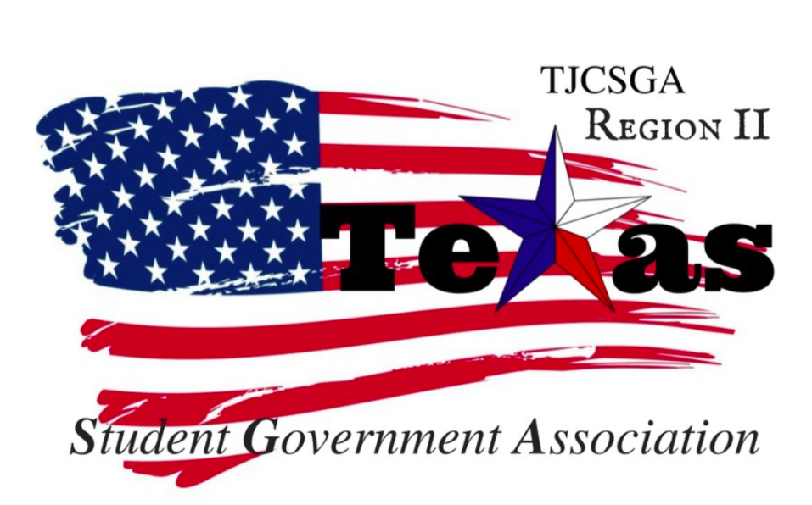
Region II Executive Board Meeting
Friday, October 13th, 2:00pm, Room W38, Mountain View College

I.Call to order (2:23 pm)
II. Roll Call-Quorum has been met
III. Reading and approval of the agenda- Approved as written so moved –host school 2nd-vice-president
No Discussion
I’s have it
Motion carried
IV. Reading and approval of the September 15th meeting minutes- Approved as written so moved host school 2nd-Parlamiterian
No Discussion
I’ have it
Motion carried
V. Opening announcements- 15 days away from the conference. We have been planned it for five months.
VI. Officer reports
A. Host School
- Edward Sesay, Richland College- Very excited for the conference. 15 days away and everything that needs to be done is complete. The programs are done, but the board needs to approve it. The rooms are booked and ready to go. We have all the break-out speakers for the conference.
B. Public Relations
- Alyssabeth Lafferty, North Central Texas College- Website has been updated. Also, I have been keeping up with the facebook page. Trying to get the executive board from NCTC to come to the conference.
C. Treasurer
- Luis Gamez, Brookhaven College-$2,986 is the current balance in our account. Richland and El certo has paid there dues for the conference. $3,105.84 is now the current balance with the dues from the colleges. The dues are due October 28th,2017. The money will be transferred to Richland directly. Will send out a week from the conference reminding them to pay their dues. Also, ask the school to bring proof of payment. They need to pay before they vote. The actual conference fee is nothing including delegate fees. We are the first board in history to get sponsors for the conference.
D. Parliamentarian
- Juan Prado, Eastfield College- Will be making dessert for the conference. We will have cheesecake.Been working on the breakout session for the conference. He will talk to his job to see if they want to be in the program.
E. Secretary
- Zaire Hickman, Cedar Valley College-Very exticted for the conference.Hope everything goes well and hope everything runs smooth.
F. Vice President
- Brittney Taylor, Mountain View College-Only committee chair position that was not filled is resolutions chair. The interviews went well. Trey Black will be our key-note speaker. The committee chairs will be coming to out October 26th,2017 meeting. They will also be there for dress-rehearsal all day the 27th.
G. President
- Alexander Bomgardner, North Lake College-Name-tag order has come and been given out to everyone.
H. Advisor
- Dr. Beth Nikopoulos, North Lake College-We do have the pins, but the design is different. We order 100 pins. The registration forms are up and running. The office of student life directors have the link to register. It will be sent out again on Monday. The committee chairs will have a pin after their term is up. Prado and I will be working on the break out session during the conference. Chancellor May is giving Phi Theta Kappa 50,000 per chapter. We are going to start working a meeting with Dr.May about this issue. We want all the clubs and organizations to get more funding. To have equal opportunity for all the clubs.
I. Advisor
- Kelly L. Sonnanstine, Richland College-If your school wants to donate things for the goodie bags.Please bring them to dress rehearsal. Suggested making cue cards on the stand, so they know what to say. Also, have them print their name and school. Richland has to make souvenir buttons. They will get buttons for completing the survey after the conference is over. Richland has been working on preferred pro noun buttons so they can have it for the conference he/she/they buttons. There will be a script for the conference, so the board members have an idea of what is going on.
VII. Old Business
A. Regional Dues-Each school needs to have proof of payment to vote during the general meeting. Richland and El Certo are the only schools that have paid regional dues. When searching for the school that has paid make sure the names line up with the payments. Treasurer will be sending out a meeting this upcoming week to remind people to pay. We will ask the schools to bring a check request / documentation to the conference. After the payment is received, we can email the schools letting them know we have gotten them payment and thank them.
B. Standing Rules
i. Roll Call and Voting methods- We want to train the committee chairs, so they know what to say and how to make a motion. This training will take place at dress rehearsal.
Mr.President entertained a motion to adopt the standing rooms as written baring grammar errors to put forth during for the general assembly
So moved- Public relationships
2nd-Host school
No discussion
I’s have it
Motion carried

VIII. New Business
A. Committee Chair Vote- We will be following region two standing rules.We will first have a voice vote. We will display on one screen a “how to” on one screen and the other screen “agenda” on the other side.
Committee Chairs
Mr. President appointed Haya Qazi for awards committee chair. The end vote was unanimous. They are in charge of voting on the awards for the conference.
Vice-president will be helping during the conference.

Mr. President appointed Nabeeha Kazmi for Legislative committee chair. The end vote was unanimous. They are in charge of amendments and changing
Parliamentarian will be helping during the conference.

Mr. President appointed Ngoc Vo Bao Huynh for social committee chair. The end vote was unanimous. They are in charge of making social events for our region. Getting people involved across all campus. If they want to have an affair the board will be in charge of paying for it.
The host school will be helping during the conference.

Mr. President appointed Victoria Rhodes for T-shirt and cheer committee chair. The end vote was unanimous. They are in charge of the t-shirt design for the region 2.
Secretary will be helping during the conference.

Mr. President appointed Jeongmin An for Recruitment& Retention committee chair. The end vote was unanimous. They are in charge of getting people involved in activities and getting people around campus.
Public Relations will be helping during the conference.

Resolutions-TBA
Mr.President will be helping during the conference.
Committee Duties-Student, Advisor
Every school in attendance will have one person to be sent to the awards committee. The board will see the ballots

B. Setup and Decorations for Conference- Everything has been squared away for the conference. Food and decorations will be are taken care of.
C. Keynote Speaker-Tre’ Black will be the key note speaker.
D. Breakout Sessions- We want to send advisors to awards, legislative. We all agreed on the breakout sessions.
E. Agenda for the Day- We all agreed at the general assembly meeting and the overall conference schedule. We want to add the state conference and spring conference to new business for the conference. Plus add the acceptance of the standing rules.
Mr. Presdient entertained a motion to accept the program as written baring grammar errors.
So moved -host school
2nd-vice president
No Dissuion
I’s have it
Motion carried
One acceptance
IX. Open Floor- We will have no delegate fees for the conference.
Mr.President entertain a motion to set the delegate fees to zero dollars per person
so moved
2nd-vice president
We set the budget for the conference for $2,500 for the conference, but lunch, breakfast and t-shirts, and programs are already paid for. Richland will pay $75 for lunch because the National Guard agreed to pay for $1,000 for food. Richland will pay $50 for candy that will come out of the regions account. Even if we don’t get sponsorships for the fall, we will have enough money to pay for the fall conference. We will just have to worry about paying for the spring conference.
Vice-president sent out the contact information for the committee chairs so we can start coordinating with our set committees.
I’s have it –Abstained Treasurer
Motion carried
X. Adjournment (4:23 pm)
Motion made by Parliamentarian to adjournment this meeting
2nd-Host school
I’s have it
Motion carried

