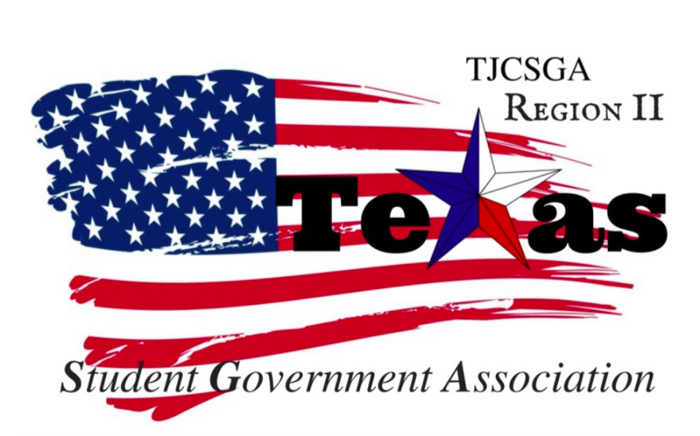
Region II Closed Executive Board Meeting
Wednesday, June 14th, 1 PM, North Lake College - room H205

I. Call to order (1:20 pm)
II. Roll Call- Quorum has been met
Richland Advisor Kelly Sonnanstine in attendance
III. Reading and approval of the agenda- approved by voice vote as written motion made by Host school, 2nd –Public Relations
No Discussion
I’s have it
IV. Reading and approval of the May 15th meeting minutes- approved by voice vote as written, motion made by Public Relations
2nd -Treasurer
No Discussion
I’s have it
V. Opening announcements
VI. Officer reports
A. Host School
- Edward Sesay, Richland College- present
- Fall conference is at Richland .They have rooms available. Conference Theme idea were given .Kelly and Edward suggest clickers for the fall and spring conference. Each college gets four clickers for a vote. We need to decide on the budget for the overall conference and pick a theme idea.
B. Public Relations
- Alyssabeth Lafferty, North Central Texas College-present
- Bio’s are all in from all the officers with professorial pictures. We will have temporary photos for place holders and take pictures again at fall conference or at the later date.
C. Treasurer
- Luis Gamez, Brookhaven College-present
- Still waiting to receive receipts and budget together from the last treasurer. Receipts from the party end of the year at Brookhaven haven’t been received yet either.
D. Parliamentarian
- Juan Prado, Eastfield College-present
- Clarification from last meeting Point of information is actually a question and not a statement . Point of order is a mistake being clear
E. Secretary
- Zaire Hickman, Cedar Valley College-present
- Excited to share ideas from Austria and how we can apply them to the region board.
F. Vice President
- Brittney Taylor, Mountain View College-present
- Package already made for the committees and suggested and adds being made. Catering proposal were passed out. The catering places suggested are already approved for DCCCD schools already. Vegetarian friendly catering.
G. President
- Alexander Bomgardner, North Lake College-present
- No response from the keynote speaker he had in mind for the conference.
H. Advisor
- Dr. Beth Nikopoulos, North Lake College-present
- Waiting for a response from district office for the meeting with the chancellor. Prices for a new gavel $50 on Amazon. Pins for the Region Board suggest $50. To keep one for you and pin the next Region board suggested as well. They will be custom pins the design will have to be sent in with the pins. Nametags suggested for the board $4-$5 dollars per nametags. State logo would go on the top left corner (TJCSGA shield).
VII. Old Business
- Committees - Application approval- Will be available online for all the schools will be able to reach it. As a board we will be looking for key words and ideal candidate for the committee chairperson. The application will be the first step of finding someone that fits the position. Picking people that will go above and beyond helping Region 2 .The applications will be emailed to the Vice-President. Then the interview will be filmed. At the next meeting the video will be showed. We are looking for people that have experience in SGA. Asking Advisors to be in the committee while they are happening. A layout needs to be created for the committee chairperson. If all the candidates are really good we can also keep them for the co-chair position. President, advisor and officer from local chapter signature will be needed on the application.
Adopted the application as written barring grammar errors
Host school-so moved, 2^{nd-} Vice President
Discussion -Question was asked about is it possible for the local SGA president eligible for a committee chair position. Questions for the candidate from the region board will be sent to the Vice-Present before the interview process.
Public- Moved to call the question
I’s have it (Voice Vote)

- Officer dates from October to March
October 13th Officer Meeting 2-4pm Mountain View (Voting will take place for Committee Chairperson)
October 26TH, 2017 Officer Meeting 3-5pm Richland College
October 27TH, 2017 will be the practice rehearsal date for the conference 9:30am-All Day process ending whenever we are done setting up Richland College
Sep 29th- Meeting is canceled from the scheduled
November 17th, 2017 Officer Meeting 2-4pm Mountain View College
December 4th -8th Finals Week
December 15th, 2017 Official Officer Meeting 3-5pm 5pm-after option to stay at the restaurant (TBA)
January 26^{th,} 2017 Officer Meeting 2-4pm Mountain View College
February 9th, 2017 Alyssabeth House (Birthday Celebration) 3pm
February 16th, 2017 Officer Meeting Brookhaven College 2-4pm
February 23rd, 2017 Officer Meeting Richland College 2-4pm
March 1st, 2017 Dress Rehearsal for the Fall Conference Richland College 3pm
March 2nd, 2017 Spring Conference (Pending approval) Richland Garland Campus
March 16th, 2017 Official Officer Meeting Northlake College 2-4pm
Motion entertained by Mr. President to adopt these dates for officer meetings
Vice President- So Moved
2nd -Public Relations
Discussion
I’s Have it Motion carried (voice vote)

C. Fall Conference
i. Date and Location-
Motion entertained by Mr.President to have the Fall conference at Richland College
2nd – Vice President
No Discussion
I’s have it Motion carried (voice vote)
ii. Budget –Olive Garden $11.50 per person for pasta bar for lunch. Breakfast preferably needs to be cheaper than lunch. Also SAMS was suggested for breakfast quick and easy.
Motion made to be set the budget $2,500 for Decorations and Food.
2nd- Vice President
Discussion - Phone banking was suggested but it takes up too much time. Also we can look for food sponsors to get cheaper food and have the company get there name out.
I’s Have it Motion carried (voice vote)
iii. Theme- There are three conference theme ideas suggested Haunted Conference, Magical World of Leaders and Diversity.
Motion made by Host school to have an open vote for the Theme for the conference.
Haunted conference for Fall Conference – Majority wins
Magical conference (Diversity Included) for spring conference – Majority wins
D. Dues, Delegate Fees, T-Shirt Pricing
i. combine delegate fees and t-shirt – Delegate fees was suggested for the students to pay. Making the event more public and having outreach to all the school in our district. Making sure we have money for everything is paid for. Dues for all school are going to be $130. Delegate fees will pay for the t-shirts and part of the food.
Motion made to rename delegate fees to conference and registration make fees $10 per person fall and spring conference.
2nd- Host school
Discussion - Pre- registration fee is $10 fall and spring conference .
Split vote 3 and 3
Mr. President –Voted No
Motion Failed

ii. Giving T-Shirts at State Convention- We can hand deliver the t-shirts before states if we do receive it.
VIII. New Business
A. Regional Ethics Policy-. The decision is not to act on the issue and stay neutral.
B. Local Chapter Officer Elections and Contact Information- Mr. President is in the process to making a giant spreadsheet with their local E-boards information. This document will include name, position, school and number.

C. Changes to Region Constitution to propose to Legislative Committee-Tabled to next meeting
D. Region 2 online presence- Tabled to next meeting
i. Email
ii. Social Media
iii. Website
IX. Closing announcements
X. Adjournment
Motion made to adjourn the meeting - Public Relations
2nd -Treasurer
No Discussion
I’s have it
Adjourned 4:14pm

