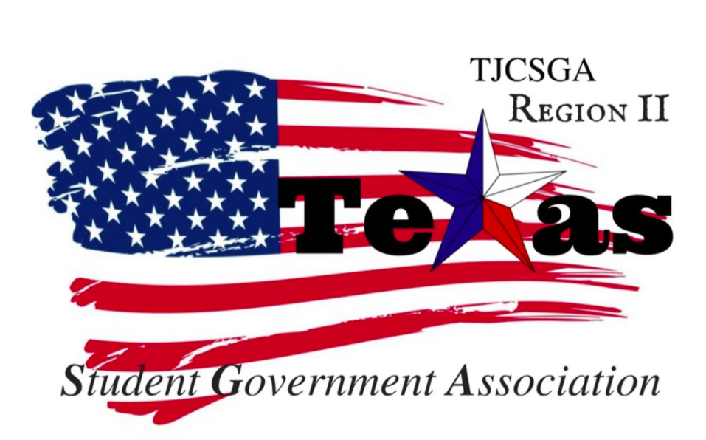
Region II Executive Board Meeting
Friday, February 8th, 2:00 pm, S003, Brookhaven College

I. Call to order (2 pm)
II. Roll Call
III. Reading and approval of the agenda –– Approved as written. By voice vote motion made by T-shirt and chair
So moved – Social Committee Chair
2nd-host school
Abstention-vice president
No discussion
I’s have it

IV. Reading and approval of the January 26th meeting minutes - Approved as written by voice vote motion entertained by Mr. President
So the moved-vice president
2nd-social committee
No discussion
I have it

V. Opening announcements
VI. Officer reports
A. Host School
- Edward Sesay, Richland College-
The adenga is ready for the conference.If you want to add anything, please let Kelly know now so she can make the changes. The food has been ordered this includes breakfast and lunch both have been taken off. There are going to be made for the scripts for the conference for every officer and chair person.
B. Public Relations
- Melissa Larin, North Central Texas College-
All of the minutes have been added to the region website. I am currently working on a flyer for the social committee event at round one. The membership list will be sent to Melissa so we can send all region two. There will be information about events that are going on within the region and will be sent to all the delegates for the reminding them about the spring conference.
C. Treasurer
- Luis Gamez, Brookhaven College-
- The total account balance is $3,399.56. Every college that will be attending the college has sent a check expect from Northlake and Collin college. There were two withdraws for the decoration for the conference that was a total of $ 414.75. The region two account is still pending and if the account goes through it will stay at Brookhaven college.
D. Parliamentarian
- Juan Prado, Eastfield College-
No report
E. Secretary
- Zaire Hickman, Cedar Valley College
- If anything is wrong in the minutes please let me know and I will change it. Also, if you have a long officer report please send it to me in email so I can make sure everything is correct and nothing will be missing in the minutes.
F. Vice President
- Brittney Taylor, Mountain View College
- Please make sure you keep your comments to a minimum so we can get through everything in the agenda.
G. President
- Alexander Bomgardner, North Lake College-
I hope we have a lot of school attend the conference and we have a better turnout better than the last conference. I hope everything goes well. We have been working hard so lets continue the hard work!
H. Advisor
- Dr. Beth Nikopoulos, North Lake College-here
Sorry for being not here the last meeting. We have had a lot of stuff to deal with. I did attend the meeting with the chancellor it was enlighten and we got a lot of information. There was money given to the college, but it was just put in the general fund. If SGA needed money, we would have to prove why we needed the money and give data for a reason why. We are working on new polices and making sure if we get funding we know where is going and what is being done with it. Since we have talked to the DCCCD chancellor we should reach out to NCTC or Collin to see if they have any problems themselves and help the out.
I. Advisor
- Kelly L. Sonnanstine, Richland College
No report

VII. Committee Reports
A. Awards Committee
- Haya Qazi, Richland College –
The meeting day we set up we have difficulty trying to get everyone at that meeting.. The day of the conference we will have two meetings. The first meeting will be explaining the awards, and the second one will be working on deciding the awards. If you do not have a representative from every school so everyone has a fair chance of voting and winning awards.
B. Legislative Committee
- Nabeeha Kazmi, Richland College-
We have a meeting on Feb 24th 12-1pm at Sablon chocolate lounge. The reason we want president and adsvior to be from two different school is because the advisor sometimes does not what to hold the position and we are trying to give everyone the same opportunity. We want to have a primary advisor tied with the president's school, and have a 2nd advisor elected by the advisors or the delegates. Maybe we can consider an Co- advisor opportunity. If we do it, we have to run the risk of adviors not steeping up and taking the position. We as a region have to also think about the commitment and investment the advisor will be making with a student that is not from their school. If we do decide to go ahead with a different school having positions. We will have to figure out the logistics of everything.

-Brain Brookhaven College
If the president and advisor are at the same school, it would be easier to talk and communicate with each other because they will be on campus and easy to access because the two are connected. If we want to separate the two, we worry have to worry about the communication on an everyday basics and to make sure they are communicating in general.
With the region two everything goes through DCCCD and the communication level. Advisor elected would be good, so they train the first year, and they can be ready for the next year. When trying to make a new amendment, we will have to consider this. If we do processed to do this we have set up a guidelines and make sure the amendment is clear so if people do want to run for these positions there is no type of miscommunication.
C. Recruitment and Retention Committee
- Sophia An, North Lake College-here
The registration link for the conference is up on the Facebook. If everyone on the board could share the link and so we can get more excitement for the conference and we can get more people hyped and ready.
D. Resolutions Committee
- Carlos Valbuena, Brookhaven College –
- Transgender students have a right to equal access to educational opportunities under Title IX. The law requires schools to respect transgender students’ gender identity with regards to dress code, names, pronouns, and more importantly access to single-sex facilities—including significantly restrooms In making up resolutions, we always should consider the student population in making decisions that directly affect us.
- Net Neutrality has proven beneficial to all students by providing us freedom to navigate the internet, and to access it from the device we chose as long as we pay for the service. Net Neutrality protects freedom of speech by not allowing private corporations to regulate what sites students can access.

E. Social Committee
- Sophia Huynh, Brookhaven College-here
Round one social event will take place on Feb 17 the 12-3;30 pm the registration link will be uploaded to Facebook.Everyone is invited. The whole purpose of the event is for socializing and getting to know people from different schools.
We are having our outdoor event " A Day Out" at Round One Grapevine Mills. We will be meeting at 12-3. Team building activity: Escape Game.
-Price: students pay individually. The game pays bowling. Escape game is 31.99/ person +tax
-The registration link is available. I already sent it to Sophia and Melissa and our Region Chat and my Social Committee chat.
Sophia and Melissa already posted for advertising and start sending out emails.
Wondering: if any of you have an email from the advisor from each school. Please send out the form so they can let their students know about the event
I expect lots of students from different college to come to join the fun and get to know each other and socialize.
Purpose of the event: mainly to bring students in region ii closer and have fun together. Team building activity also increases trust among each other.
Additional purpose: If anyone has anything to donate to homeless or any donation for pets,
please bring it.

F. T-Shirt & Cheer Committee
- Victoria Rhodes, North Lake College-here
- Kelly brought t-shirts for us to feel the material that we should go with. The material X-temp that is the material. The SGA t-shirt for both side the existed prices will be XS-XL $6.15. The t-shirts will be first be charged to the region account. Then whatever the school ordered they will be charged for that amount of money. There will be a mock-up of t-shirts both with the flag logo and the star logo. It will be sent to the email and group me. The t-shirt will be ordered after the spring conference. The qulatrics link will include a t-shirt size so we can get and estimated count.
VIII. New Business
Conference Agenda- There will be a new photo take of the officer board the next meeting so we can have Mellissa in the new program. The program needs to printed and ran by at least the 23rd after we meet. The commeetiee chairs will take individulal photos that will go in the program for the sping conference. So everyone come dressed and look nice.

The conference agenda
Vice-president moved adopted the current the agenda and baring the pictures we still need to take
2nd-Host School
Abstention- t-shirt and cheer and Recruitment and Retention
I’s Have it
Motion carries

- Breakout sessions - 'sorting hat.'
Mr.President, entertained a motion to sort the people out into house just like in harry porter to go with the theme these groups will be the breakout session.
So moved- Host school
2nd – Awards Committee
Abstention – Parliamentarian and Recruitment and Retention
I’s Have it
Motion carries

- February 16th Meeting
Mr.President entertained a motion to get rid of the meeting on Feb 16.
So moved-Host school
2nd-Vice President
Abstention –social commetiee and t-shirt
I’s Have it
Motion carries

IX. Open Floor – We will be getting nametags for the committee chairs. We do not have a meeting on March 2nd we will be meeting at 1 pm to set-up for the conference .Do not come to any earlier because there will be a professional development day. The script will be emailed and sent out. Please will all the committee chairs please email Kelly a summary of what they will say the day of the conference. One the day of the conference we have to be an hour to 30 minutes early to put the finishing touches on everything.
X. Adjournment (4:42 pm)

