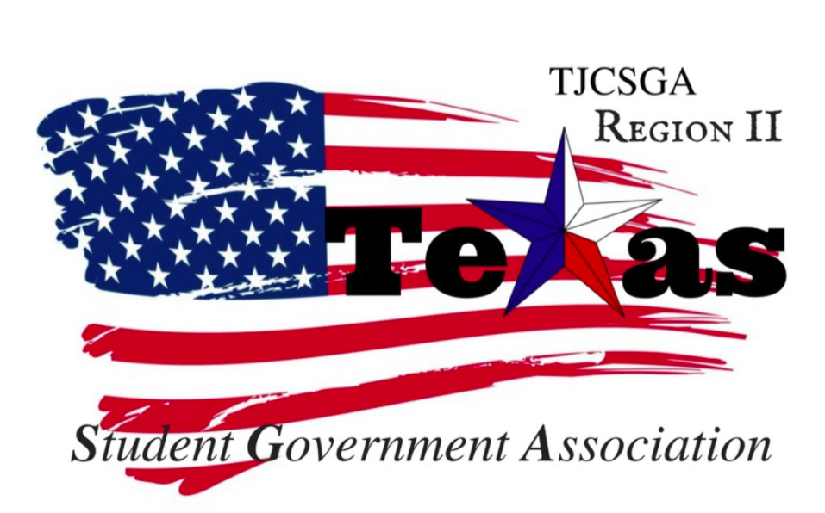
Region II Executive Board Meeting
Friday, December 15th, 3:00 pm, Cheesecake Factory

I. Call to order (2 pm) Actual Start Time 3:17 pm
II. Roll Call
Host school –present
Treasure – present
Secretary-present
Public Relations -present
Parliamentarian. – present
Vice President-not present
President- present
Dr. Beth Nikopoulos- North Lake College- Present

Haya Qazi, Richland College-present (Awards)
Nabeeha Kazmi, Richland College (Legislative)
Sophia An, North Lake College (Recruitment and Retention)
Carlos Valbuena, Brookhaven College (Resolutions)
Sophia Huynh, Brookhaven College (Social)
Victoria Rhodes, North Lake College (T-Shirt & Cheer)
Quorum has been met

- III. Reading and approval of the agenda- Mr. President entertained a motion to approve agenda as written and baring the incorrect date.
Host school “So move” the motion
T-shirt & Cheer -2nd
I’s have it
No discussion

IV. Reading and approval of the October 13th meeting minutes- Trisha- North Lake move to approve the minutes as written baring any grammatical errors. Host school-
Social committee -2nd
I’s have it
No discussion

V. Opening announcements- We have a newly elected person from NCTC College. Melissa is very excited for this new opportunity as being public relations officer. Melissa is excited about the upcoming year. We went around the table and introduced ourselves, so Melissa can get to know everyone.

VI. Officer reports
A. Host School
- Edward Essay, Richland College- Everything is on the right track for the conference. Haya and I have been working on the floating candles. The National Guard sponsorship is in the works.
B. Public Relations
- Melissa, North Central Texas College –She will get into contact with Alyssabeth for the camera and access to the Facebook page. Just bear with me this whole new process is new so just work with me and be patience.
C. Treasurer
- Luis Gamez, Brookhaven College- There was an email sent to Beth from the Richland’s business officer demanding money from the region account. Northlake requested to move the money to Richland and they said could not and would not transfer money. Beth filled out to write a check to Northlake to Richland.
D. Parliamentarian
- Juan Prado, Eastfield College- Spoke about the the new E-board member. It is supposed to a board of the decision to pick a new person. Just wanted everyone to know this and also, wanted to welcome Melissa apart of the new board.
E. Secretary
- Zaire Hickman, Cedar Valley College- Announced that she is the new Ms.Cedar Valley and that is why I was not present at the last meeting. I am glad to be back and ready to work for this new upcoming year.
F. Vice President
- Brittney Taylor, Mountain View College-not present
G. President
- Alexander Bomgardner, North Lake College- Regarding the new officer elected as public relations officer I hope this doesn’t have to happen again. Prado, thank you for keeping me honest. Luis, I amend you with dealing with the business officer. Zaire, the minutes are amazing to keep it up. Beth, thank you fro being an amazing advisor for the region board.
H. Advisor Brookhaven.
- Dr. Beth Nikopoulos, North Lake College- Beth filled out to write a check to Northlake to Richland. We will have to make an account outside DCCCD. We have to contact the IRS and the state of Texas. We have to get an account connected with the corporation. All the money should be in the account by January the latest.

- Kelly L. Sonnanstine, Richland College-not present

VII. Committee Reports
A. Awards Committee
- Haya Qazi, Richland College- We decided as a board to vote on the new awards and the guidelines themselves. We put them on the Google docs so everyone can go to the doc and edit them. They have been sent to vice-president as well.
B. Legislative Committee
Nabeeha Kazmi, Richland College- Since we are having and outside account, we will be have to add new amendments to the Constitution . We added a cover page, table of contents, and page numbers in our first meeting.

Amending Article XIV- “each officer is allowed one excused absence per semester. The second absence will result in a written warning from the region advisor…One additional absence shall be reserved in the wake of an emergency”

Adding a section 2. “Classifying which situations are considered an emergency is up to the discretion of the Advisor of the President School that was sworn in with the officers”

Adding a section 3. “If a member is not able to physically participate in a meeting, they should look for alternative ways to join such as through video chat or voice calls. ”

C. Recruitment and Retention Committee
- Sophia An, North Lake College- Rising and canes will be sending us gift cards cards for lemonade 100 of them for the goodie bags.
D. Resolutions Committee
- Carlos Valbuena, Brookhaven College- We will be meeting with Justin
- January 11th NCTC 10 am will be the next meeting. We want to get ahead of the game because the next year we will have sessions and want to get with Justin to get help on that. We want to invite all schools to be apart of resolutions committee. We want at least one person from each school
- E. Social Committee Sophia Huynh, Brookhaven College- We have decided will having a spring formal dance.Northlake 6-9pm March 9rd.At the dance, we will have winter king and winter king. When registering you will be notimating who you want to become king and queen. You can pay at the door also. Your local SGA will be notmating .The people will submit a paragraph why you should be the king or queen. Nabeeha and I were looking to buy lights for the dance and also asking theater for lights .Edward got a DJ for the dance, and that will be for free. We will be making flyers for the dance. We are going to start putting the word soon for everyone. We are working one to reserve a room in H building. We need to contact the campus police to see if they will be available. The age requirement will be 16 years old and older. We are expecting 50 to 100 people. The budget will be 250 dollars .$10 per person. Couples $15. Four people $30.
- Sophia moved to make a motion to set a budget for the formal spring dance for $250
- What will happen if we spend $250 on this winter formal what will happen and we lose money for lack of participation. Sophia will not be able to pay back the money if we lose it Pizza will be provided.
- I’s- 6
- Nays-2
- Abstentions -2 Tresurer and Parliamentarian
- I’s have it motion carries
- Parlimataion move to table this current motion to next meeting
F. T-Shirt & Cheer Committee
- Victoria Rhodes, North Lake College- I was notified today that we would have to make more t-shirt options for schools to choose from.
- November 26th we had a meeting regarding the t-shirts and was asked how many t-shirts we will be ordering.
VII. Old Business
- Lunch for Spring Conference – Someone suggested that we have a self-serving cold-cut bar. Where you make your own sandwiches. There will be different kind of bread, meats, and cheese. We are still trying to find sponsors for the lunch for the conference. There will be a vegan option. This is just an idea for the conference. Salad should be an option to. Tacos were suggested with salad. We want to have variety and options. Indian style food was suggested as well too. Bento box was suggested from Prados workplace. Was suggested for the budget $1,000-to feed 110 people $9 per person. Merritadean, Taco/Salad Bar, Bento Box

B.Breakfast- Sam’s Club there has been a motion made to get Sam’s Club for breakfast
Haya-2nd motion
Sams’s has a lot of options for breakfast. We can get pastries and fruits, coffee and other such things. Zaire or Victoria will be able to go to sams because they have Sam’s card.

VIII. New Business
- Key- note Speaker- The key-note speaker will be professor Mamzy from Richland college. He is very glad to be our speaker for the conference. Edward moves to select professor Mamzy from Richland college to be the key-note speaker for the spring conference.
2nd-t-shirt
no discussion
one abstaintion treasurer
I’s have it

- Bone Marrow Donation- Be the Match- It is the US registered to donate blood/ bone marrow to people that need it. They get a check swap to get your DNA. Once you register, it doesn’t mean you will be a match, but if they need you, they will call you. They are looking for people of the ages around 18-44. This will take place before lunch. This will be an on-site process it will take places after we still leave the spring conference because they will contact you to give you a donor card. We also can host bone marrow drives at our host school.

January 26th meeting location –Cedar Valley
C.February 9th meeting location –Brookhaven

Parliamentarian moved to move the location of Jan 26th to cedar valley and move the Feb 9th meeting to Brookhaven
2nd by –t-shirt and cheer
I’s Have it
Motion passes

IX.Open Floor- Try to get the state E board to come to the spring conference. There will only be a person from Eastfield attending the spring conference. Keep on eye out for people for the next region meeting.
X. Adjournment (5:30 pm)

