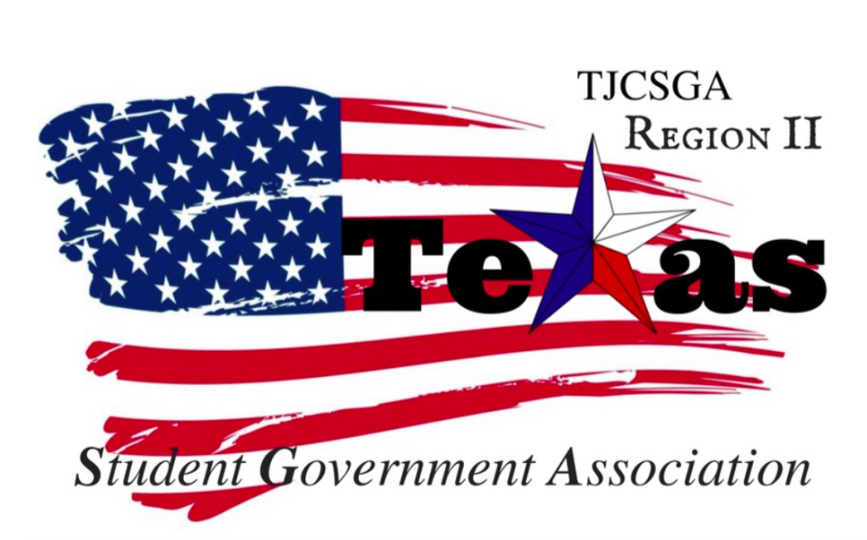
Region II Executive Board Special Meeting
Tuesday, August 8th 2017. DCCCD Office

I. Introductions (photographs if permissible)
II. Student E-Mail
A. Concerns about freely sharing Student ID number- Automatically the numbers are internally generated. A new IT for students and staff are in the works. The system will include a new way to process information.
B. Have email system to faculty and staff; front end vs. back end- Two emails are a necessary for communication. Moving towards a two-step login as add on. Cloud based system. The students will give their own emails later on.
III. DART GoPass
A. Issues with obtaining physical GoPass- The GoPass they are in the process of working out the kinks of the app and how it processes. You will need to update your phone for it to work correctly. Getting more students involved with the pass and having as many students Even if the pass is not needed by the students they can get a pass for just a backup plan. The pass can be used whenever. Making it to where students can go to someone directly for the issues. Not through Dart. Trying to make it to where campuses have stickers for the GoPass. Creating and over all awareness of this issue with getting a pass. If the sticker was made more available it would be made easier for students. Focus group for would be made for the Dart Pass and the over all process.
B. Have DART to send schools a bulk number of physical passes instead of needing two wait two weeks to obtain 1 sticker.

IV. Campus Carry
A. Schools and students still do not have knowledge of which areas will be gun-free zones
V. Gender Neutral Bathrooms
A. State legislature currently debating bathroom bill, sparked by national interest in
Transgender individuals. - Dr.May is very-concerned regarding the individuals regarding the issue and they we do respect all the students. Also the conversation about for exactly for who it applies to. As it written right now it would apply to use. Waiting for the session to play out and see where it goes.
B. Possible restrooms DCCCD could have are Family Bathrooms, or multiple single-stall
restrooms.
VI. Communication between the students and the district
- DCCCD cannot solve problems that it is not aware of-Chancellor deals with polices and the accountability piece of the college. The college takes the ideas and uses this as a guide. At the district level they do not determine the budget for their programs.
Also they can a meeting and creating a feedback loop. Creating for normal meetings with the local SGA presidents, and having them meet and get feedback from their local colleges. Nothing is better than word of mouth of the students.
B. Since TJCSGA Region II extends beyond Dallas County, have meeting with SGA
Presidents from DCCCD Schools once per semester or year
VII. Questions from Chancellor May to Region II Board-
There was talk about creating new positions for registering and a transfer plan. There is a new App development for the students for interaction. That will help assisting the advisors in this process. There will be a whole new processing system set in place. Two parts to solving this process having a technology side and updating the system .Also a change of service and altitudes. Making sure getting what the students what they need. Breaking down the barriers and making sure the students have all the opportunities to attend school.

