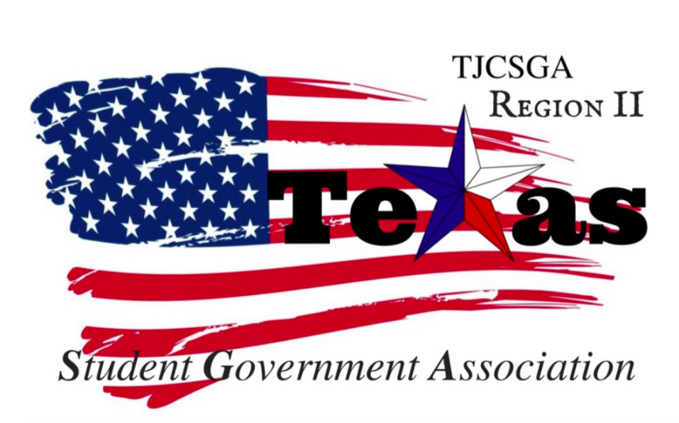
Region II Executive Board Meeting
Friday, August 13th, 2:00 PM, Richland College - room EO81

I. Call to order (2:10 pm)
II. Roll Call- Quorum has been met
Richland Advisor Kelly Sonnanstine in attendance
III. Reading and approval of the agenda-- approved by voice vote as written motion made by Host school, 2nd-vice president
No Discussion
I’s have it
Motion carried
IV. Reading and approval of the previous meeting’s minutes– approved by voice vote as written by host school
2nd-vice president
No Discussion
I’s have it
V. Officer reports
A. Host School-here
- Edward Sesay, Richland College-Everything is ready for the conference. The only thing that is not set up is the breakfast and lunch.
B. Public Relations-video call
- Alyssabeth Lafferty, North Central Texas College- Nothing to report at this time.
C. Treasurer
- Luis Gamez, Brookhaven College - absent
D. Parliamentarian-here
- Juan Prado, Eastfield College-Nothing to report at this time.
E. Secretary-here
- Zaire Hickman, Cedar Valley College-Nothing to report at this time.
F. Vice President-here
- Brittney Taylor, Mountain View College-Nothing to report at this time.
G. President-here
- Alexander Bomgardner, North Lake College-Nothing to report at this time.
H. Advisor-here
- Dr. Beth Nikopoulos, North Lake College- The name tags have not been ordered yet. The writing on the nametags will say TJCSGA Region Two on it.
VI. Opening announcements-Leadership Summit will be on September 30th, 2017. This conference will last all day. It will take place at the Bill J Priest building in Downtown Dallas.
VII. Old Business- No old business.
VIII. New Business
A. Sponsorships from Universities- We are still in the process of looking for sponsorships to donate an entire meal for the conference or even giving money towards the conference. If school decide to donate it could be an excellent way to reach students and have a more personal connection to their transfer students. Universities could say a few words about their school and the programs they offer. A mini recruit fair will take place during the conference so the schools can interact with the students. A panel discussion will happen with each of the different universities. The students can ask the questions directly to the universities that they will plan to attend. They also will have set questions that they the board will give them beforehand. Also, we are reaching out to the student government president's at the campus for a direct person to talk to regarding the schools attending the conference.
Four level for scholarships
$100- Will be a booth at sign table at breakfast & lunchtime
Their name will include the program

$250-Will have a booth and participation in the panel plus will get them a name and logo in the program

$500-(only one school for this slot and they will provide Breakfast) Booth name and logo on program, participation in panel, special shout out during the afternoon meeting(1 or 2-minute promotion)

$1000-(only on school for this slot and they will provide Lunch) Booth name and logo on program, participation in the panel, Shout out during the email being sent out and a special shout out during the afternoon meeting (1 or 2 minutes for promotion)

The panel will be set up and will have information about transfer students and scholarships they will have to offer for the students.
Motion made to adopt these scholarships criteria for the conference
2nd-Vice President
I’s Have it
Motion Carried

President Entertained that each board member will have the motion to act with full authority to talk to university about sponsorships
2nd-Vice president
No Discussion
I’s have it
Motion carried

B. Conferences
i. Spring Conference -The Garland campus will not have enough room for the conference. The spring conference will be moved to Richland’s Central March 3rd, 2018.
Host school moved to make a motion to make to spring conference to Richland’s central March 3rd,2018.
2nd-Parliamentarian
No Discussion
I’s have it
Motion carried
ii. Agenda- There will be a new agenda layout for the conference. We will be using Region Five last year’s agenda for reference. The committee meetings are going to last for about an hour. We will have least an hour 15 minutes for lunch, then have the speaker talk the last 30 minutes during the lunch time. As a board, we need to meet with committee chairs to give them an outline of what to go over. Everyone should have a quick Robert rules training. Also, we will need to include an advisor meeting during the first break out session. There will be least one advisor in each committee meeting. A rough draft agenda will be typed up for the fall conference and will be sent out for editing. Qualtrics is going to be used for registration table for the Fall conference. It is an online check-in database making it easy to keep everyone contact information together and all in one place.
Committee List
Resolutions-President
T-Shirt & cheer- Secretary
Legislative-Parliamentarian
Awards-Vice President
Recruitment and Retention- Public Relations
Social- Host School
iii. Standing Rules-Tabled till next meeting
iv. Robert's Rules rundown before business meeting- Just a quick rundown of what to expect. There will be five or ten minutes set aside to go over the basics. Roberts rules and roll call right before the business meeting.
C. Recap of Meeting with Chancellor May-Finding a more efficient for students to get a Dart pass and handle the issues they have with the pass.
D. Questions for Committee Chair applicants- SGA office and advisor signature will be added to the application.
Why do you want this position?
Who are you?
How can you make an impact by having this position?
What are you currently involved in?
What do you want to learn from this experience?
How familiar are you with Roberts Rules?
Do you know how to draft a constitution?
Are you aware of how to draft and write a amendment/resolution?
IX. Closing announcements- Remember that the next meeting will take place at Northlake on September 1st 2017 2 pm.
X. Adjournment-3:58pm

