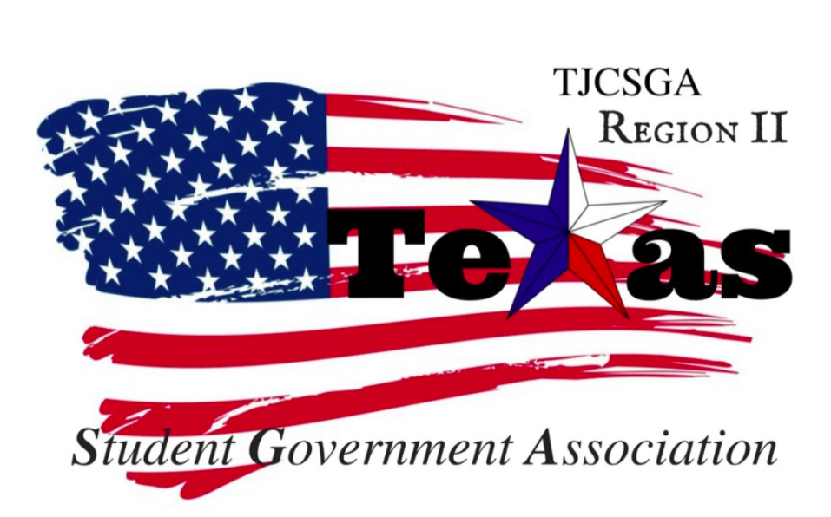
Region II Meeting
Thursday, April 5th ,2018 , 8:00pm, TJCSGA State Conference

I. Call to order (8:09pm)
II. Roll Call
III. Reading and approval of the agenda- Richland College moved to dismiss the reading and the approval of the agenda. Northlake College seconds the motion
No discussion
2- Nays from Northlake College
Parliamentarian-abstained
I’s have it
Motion passed

IV. Reading and approval of the March 3rd ,2018 meeting minutes- Brookhaven College moved to table the reading and the approval of the March 3rd ,2018 meeting. Northlake College seconds the motion.
No discussion
I’s have it
Motion passed

Roll Call –
Brookhaven College 13 delegates 2- advisors
Cedar valley College 6- delegates 2- advisors
Collin College 1- delegates 1- advisor
Eastfield College 10- delegates 2- advisors
El Centro College 7 – delegates 1- advisor
Mountain View College 3- delegates 1- advisor
Northlake College- 15 delegates 2- advisors
Richland College 4- delegates 1- advisor
Tarrant College 7 delegates 1- advisor
Tarrant county North West 16 -delegates 2-advisors
NCTC -13- delegates 2- advisors

V. Opening announcements-
VI. Officer reports
A. Host School
- Edward Sesay, Richland College- Thank you for everyone that attended the spring conference. We had 89 people come to the conference. I hoped everyone had a great time at the spring conference. It has been an amazing opportunity for Richland college and me to hold this position as Region Two host school!
B. Public Relations
- Melissa Larin, North Central Texas College- All the pictures from the spring conference have been uploaded to Instagram and Facebook page. I will be taking the pictures all throughout this weekend so make sure you are keeping up with the social media links.
C. Treasurer
- Luis Gamez, Brookhaven College- I am glad to see some many faces in this room. It is amazing opportunity to be here and to have everyone here in this room. My sincere my apologies to Tarrant Country college for ya’ll not having t-shirts this evening. I did reach out and try to send invoices to your advisor but, no one ever responded back to my emails.
- Also, if all the Region Two advisors can email your invoices Please for all the advisors can you email me your invoices for the t-shirt orders.

The account is finally going to be at Brookhaven College. When the money is transferred over the account will no longer be at Richland College.
D. Parliamentarian
- Juan Prado, Eastfield College –I would to thank everyone for being here. Our voices really need to be heard in the General Assembly meeting room. Please don’t be afraid to stand up and talk. Region Two will be heard this state conference.
E. Secretary
- Zaire Hickman, Cedar Valley College- All the minutes are on the website. The spring conference minutes will be sent out to everyone. All the minutes that I take at the minutes will be done by the next Region meeting.
F. Vice President
- Brittney Taylor, Mountain View College-It has been a pleasure being on this E-board. Region two needs to make history again. We wil make an impact and make sure that all the regions know who we are.
G. President
- Alexander Bomgardner, North Lake College- On the march 23rd executive board we trained all the members
- Nomations –sophia han
- Judical –Norman mardia
- Resolutions – Carlos
- Legstive commeitte –
- Awards – Brittany Taylor , Marshay Collins ,
- Historian- open commeitte
- Constions and bylaws commettie- Nabela
H. Advisor
- Dr. Beth Nikopoulos, North Lake College- It is great to see both Tarrant Counties here . I am really grateful to have NCTC on the executive board. It has been years since they have held a Region executive position. Please do think of running for an officer postion. If you do participate to run it will make a difference in your life. I am really grateful to have Kelly Sonnanstine for being the Co-advisor for the board. She has done an amazing job with Hosting the conference and helping out the region board.
I. Advisor
- Kelly L. Sonnanstine, Richland College- Thank you again for being here. If you are thinking of running for a Region or State position do it! It does not hurt to try and broaden your horizons. I know for sure we have a room full of great leaders you just have to take a chance and it will all play off.

VII. Committee Reports
A. Legislative Committee-not here
- Nabeeha Kazmi, Richland College – no reports
B. Resolutions Committee
- Carlos Valbuena, Brookhaven College- I have submitted the resolutions on the state level. The chair of the state committee still has not gotten back to me. When I get a respond back I will be sure to make sure the Region knows.
C. Social Committee
- Brookhaven College- TJCSGA partnered with Richland College to hold a social event. The event that was held was a flag football tournament. It was a great turnout. Everyone came out to support Region two .Special thank you for Richland College Student ambassadors for partner with us on this event and helping set it up. Another thank you for Richland College for allowing us to have the event at their campus.
D. T-Shirt & Cheer Committee
- Victoria Rhodes, North Lake College- If anyone wants a copy please make sure you get with me so I can email you all of them so you know them We will be doing these chants as a group and I want to make sure that everyone knows the words to all of them.
VIII. New Business– Intent to run for Region and State Positions
Brookhaven College –Host school on state level
Brookhaven College-Region Two Secretary
Tarrant County College- Region Two Treasurer
Northlake College- Region Parliamentarian
NCTC College- Region Two Host School

If you do want to run your school will hold the position. A school can have multiple positions on the region board.

The chair entertains a motion to have 10 minute recess
Brookhaven- 2nd Seconds
No discussion
I’s Have it
Motion Passes

B. Campaign Guidelines- We will be using the state campaign guidelines. They are located on the TJCSGA website and Event XD.

IX. Adjournment- All throughout the state conference the attire is professional and it is required the whole time. Thursday is the only day that you can be causal and the evening’s event you can wear whatever you want. Please follow the state dress code guidelines and make sure you are aware of how you are presenting yourself and Region Two.
(8:51pm)

